FSE100 Individual Assessment: Engineering Design Process

A concept map is a diagram that is used to organize and structure information and it depicts relationships between different pieces of information. A concept map contains ‘concepts’ which are words or phrases placed inside boxes, lines or arrows connecting these boxes to show their relationships, and words/phrases next to the lines/arrows indicating the relationships. Below is an example concept map showing key features of concept maps.
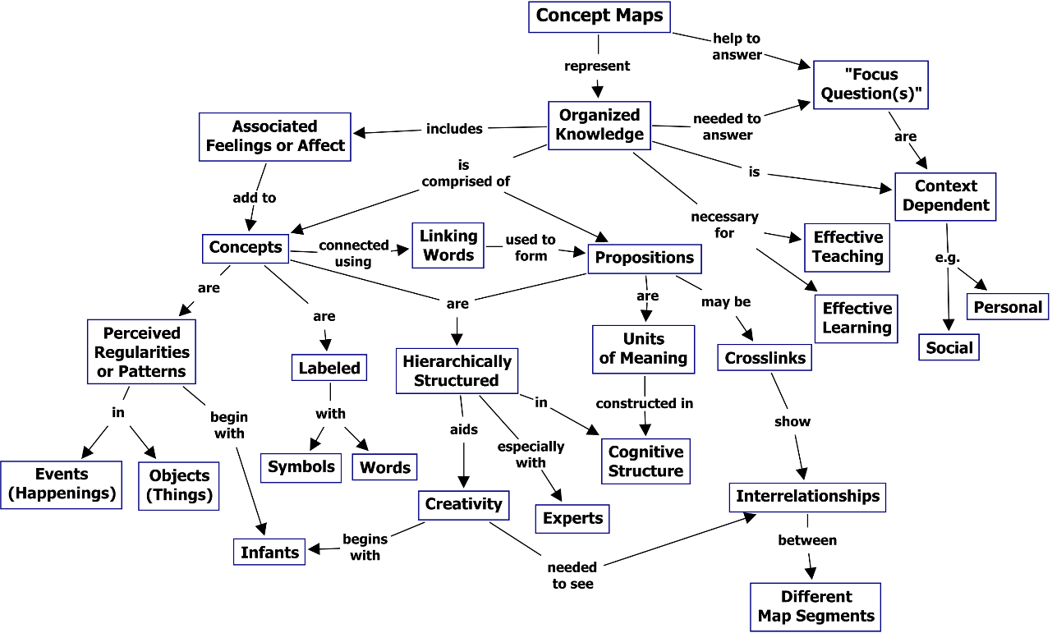

Your task is to create a concept map (on the next page) that demonstrates your current understanding of the Engineering Design Process. Make sure that your concept map

- includes the steps as well as important concepts in the engineering design process – some examples of important concepts include
  - key tasks involved in the steps;
  - possible outcomes for the steps;
  - tools & techniques & strategies that are appropriate to accomplish the tasks/steps;
  - etc.
- includes sub-branches and connection lines & arrows that show connections and relationships between the concepts and steps;
- shows the characteristics of the engineering design process.

Also write a short paragraph (2-3 sentences) to describe your concept map.

https://en.wikipedia.org/wiki/Concept_map
http://cmap.ihmc.us/docs/theory-of-concept-maps

