ES 2501: Introduction to Static Systems
Worcester Polytechnic Institute
D-Term 2016

Professor: | Glenn Gaudette
Lecture: | M, T, W, R, F 8 – 8:50 am,
Office Hours: | M, T, W, R, F 9 – 9:50 am, Room – GH 310
TA: | TBD
TA Office Hours:
Grader: | TBD
Recommended Background: | differential (MA 1021) and integral (MA 1022) calculus, vector algebra (MA 1023), and double and triple integration (MA 1024)
Text: | Hibbeler, R. C. Statics. 14th ed.: Pearson

Course Description:
This course is designed to teach you to how to begin to mechanically analyze the physical objects in the world around you. You will learn how to look at systems and determine how to model the forces and reactions for statically determinate systems. The course will begin with a review of vectors to aid in the analysis of three dimensional systems. You will learn to model real world systems as points and rigid bodies for simplified analysis. Equations of static equilibrium will be used to determine reaction forces. This course lays the foundations for the material covered in ES2502 (Stress Analysis).

Course Policies:
- Problem Sets: Problem sets will generally be assigned as shown on the schedule. These assignments will include the material covered in the classes just before and after the assigned date. To maintain pace with the course, it is recommended that you work on problems every night to apply the material learned in class that day, rather than waiting until the night before the assignment is due. Some of the problems that will be assigned will be difficult to give you the opportunity to critically think about the skills that you are practicing/applying. Please do not wait until the last minute to start working on them! Problem sets are your chance to both practice the skills that you are learning in class and challenge yourself to see how these skills can be applied to the world around you.
- Late Policy: Assignments are due at the beginning of class on their due date. Problem set solutions will be posted shortly after the class in which they were due. As such, no late problem sets will be accepted and you will receive a zero for the missed assignment. (Note: Your lowest problem set grade will be dropped.)
- Exams: There will be four (4) 1-hour exams throughout this course. These exams will be taken in class, closed book, on the dates listed in the course schedule. Bring a calculator and ruler for all exams. One (1) single sided sheet of notes may be prepared, hand written only, and used for your reference during the exam time. Your reference sheet is for your individual use only and may not be shared during the exam. Your writing of this reference sheet may help you in preparing for your exam!
- Calculators: Bring your calculator to class as you may be solving problems during class time.
- Hands on Learning Days (HOLD): During the term, activities are planned to reinforce the concepts learning in the course. The class will be divided in half groups (posted on Canvas) to do hands on activities related to the lecture content. A major portion of your participation grade will be based on your attendance to these labs. As such, attendance will be taken. You will only get your participation points by attending the correct time section.
- Academic Honesty
  - “Academic honesty is a fundamental principle of learning and a necessary foundation for all academic institutions, particularly those dedicated to independent project-based education, such as WPI. Violations of the principle deny the violators an opportunity to obtain confident command of the material they are credited with knowing, cheat their classmates out of deserved rewards and recognition, debase the institution, and demean the degree that it awards.” If you are unfamiliar with the WPI Academic Honesty Policy, in can be found in the Code of Conduct on the WPI website at http://www.wpi.edu/Images/CMS/CampusLife/code-of-conduct.pdf
  - Problem Set Collaboration: Good faith collaboration on problem sets is strongly encouraged. Students should first make an independent serious attempt at each of the problems within the problem set, and only then discuss the problems with others to clarify difficulties. With this type of collaboration, the details of problem sets will likely be different even for students who have assisted each other with the assignment. Remember, practice problems are your chance to practice and hone the skills learned in class that will be utilized on exam and in your current/future engineering career.
- Disability Services
  - If you need course adaptations or accommodations because of a disability, or if you have medical information to share with me that may impact your performance or participation in this course, please make an appointment with me as soon as possible.
  - If you have approved accommodations, please go to the Exam Proctoring Center (EPC) in Morgan Hall to pick up Letters of Accommodation.
  - If you have not already done so, students with disabilities who need to utilize accommodations in this class are encouraged to contact the Office of Disability Services (ODS) as soon as possible to ensure that such accommodations are implemented in a timely fashion. This office can be contacted via email: DisabilityServices@wpi.edu, via phone: (508) 831-4908, or in person: Daniels Hall First Floor (124 or 137).

Class Schedule (subject to change based on course pace)
Week | Day | Date | Topic | Reading For Class | Key Due Dates
1 | M | 3/13 | Introduction & Overview, General Principals | 1.1-1.4
 | T | 3/14 | Vector Review | 2.1-2.3
 | W | 3/15 | Resolving vectors into Cartesian Coordinates & 3D vectors | 2.4-2.6 | TBP #1
 | R | 3/16 | Position vectors/forces, Dot products in 3D | 2.7-2.9 | HW 1
 | F | 3/17 | HOLD – Vectors or  Particle Equilibrium/FBDs | 3.1-3.2
2 | M | 3/20 | HOLD – Vectors or  Particle Equilibrium/FBDs | 3.1-3.2 | HW 2
 | T | 3/21 | 3D Particle Equilibrium | 3.3-3.4
 | W | 3/22 | EXAM DAY |  | Exam 1
 | R | 3/23 | Moments and Cross Products | 4.1-4.2
 | F | 3/24 | HOLD – 3D Particle Equilibrium or Moment of a Force | 4.3-4.4
3 | M | 3/27 | HOLD – 3D Particle Equilibrium or Moment of a Force | 4.3-4.4 | TBP #2
 | T | 3/28 | Moments about specific Axes, Moment Couples
 | W | 3/29 | Equivalent Systems | 4.5-4.6 | HW 3
 | R | 3/30 | Distributed loads | 4.7-4.8
 | F | 3/31 | EXAM DAY |  | Exam 2
4 | M | 4/1 | FBDs
 | T | 4/2 | HOLD – Moments or  FBDs/Support conditions | 4.9
 | W | 4/3 | HOLD – Moments or  FBDs/Support conditions | 5.1-5.2
 | R | 4/4 | Equations of Equilibrium | 5.5
 | F | 4/5 | HOLD - FBDs or  Equations of Equilibrium | 5.3 | HW 4
5 | M | 4/10 | HOLD - FBDs or  Equations of Equilibrium
 | T | 4/11 | Two Force Members
 | W | 4/12 | EXAM DAY |  | Exam 3
 | R | 4/13 | Trusses/Method of joints/zero force members |  | HW 5
 | F | 4/14 | Trusses/Method of sections | 6.1-6.3
6 | T(R) | 4/18 | HOLD – Rigid Body Equilibrium or Frames and Machines | 6.4 | HW 6
 | W | 4/19 | HOLD – Rigid Body Equilibrium or Frames and Machines
 | F | 4/21 | EXAM DAY |  | Exam 3
 | M | 4/24 | Internal loading | 6.6
 | T | 4/25 | Internal loading | 7.1 | TBP #3
7 | W | 4/26 | Shear and Moment Diagrams
 | R | 4/27 | Shear and Moment Diagrams | 7.2-7.3 | HW 7
 | F | 4/28 | COM and Centroids
 | M | 5/1 | COM and Centroids | 9.1 | HW 8
 | T | 5/2 | EXAM DAY |  | Exam 4

Problem Set (Homework) Formatting:
Problem sets should be completed in a neat fashion such that it can be used as a study tool for both your exams and as a resource when you have been working for 10 years and need to remember how to apply the equations of static equilibrium or other concepts. These should be standalone documents that would not require you to refer back to your old text book (that you probably lost over the years) to figure out for additional explanation when you look at them in the future. When working on projects with others in the working world or in class, it is easier and less error prone to communicate using a neat and organized system. The following homework requirements will be used in this class and will help guide you in finding your own personal style.
- The version of your problem set solutions that you turn in should be a final draft of your work that is done after you have worked out the problem on scrap paper.
- Problem sets must be completed on engineering paper (you can get this at the bookstore).
- Only write on the front side of the pages you are submitting.
- Each problem should start on a new page.
- Pages must be stapled together in the upper left hand corner.
- All numbers should be accompanied by their units (unless the value is unitless).
- A straight edge should be used for all lines drawn unless you are able to draw a freehand line that is as straight as one drawn with a straight edge.
- Page headings should follow the format shown in Figure 1. The first page must include all of the information shown, following pages need only page number information.
- For each problem the following sections should all be included in the following order, working down the page as you solve the problem.
  - Given: This section is a summarized restatement of the problem that was given. It may include drawings, values for constants or variables, theories, or anything else that was given in the problem statement. All given labels should be included in your drawing. (If you want to take a screen shot of the images from the homework and print them on engineering paper in this section that is fine, just make sure it’s printed at the correct location on the page.
  - Find: In this section, you state what you are trying to find in the problem. What are you solving for?
  - Assumptions: In this section you write the assumptions that you are using throughout the entire problem. Examples of assumptions may include: negligible gravitational effects, rigid bodies, static equilibrium, etc. You may want to leave some extra space here as you go through the problem, as you may realize there are more assumptions that you need to make as you do your analysis.
  - Analysis: In this section you write out your step-by-step solution to the problem. You should state what theories and assumptions you are using as you go along (assumptions are listed in their own section earlier as well). If you have a picture in the “Given” section, you will likely have at least one picture in your analysis section (free body diagram, other). All relevant items should be labeled in your drawings. It is good practice to solve problems symbolically first and then substitute numbers into the final solution. Your final answer must be boxed in, with units when applicable.
  - Explanation: In this section you will write a brief (1-4 sentences) as to why your answer makes sense. This could be based on your understanding of the problem, an analogy, unit checking, intuition with an explanation, other. This section is to give you space to reflect on your final answer to make sure it makes sense.
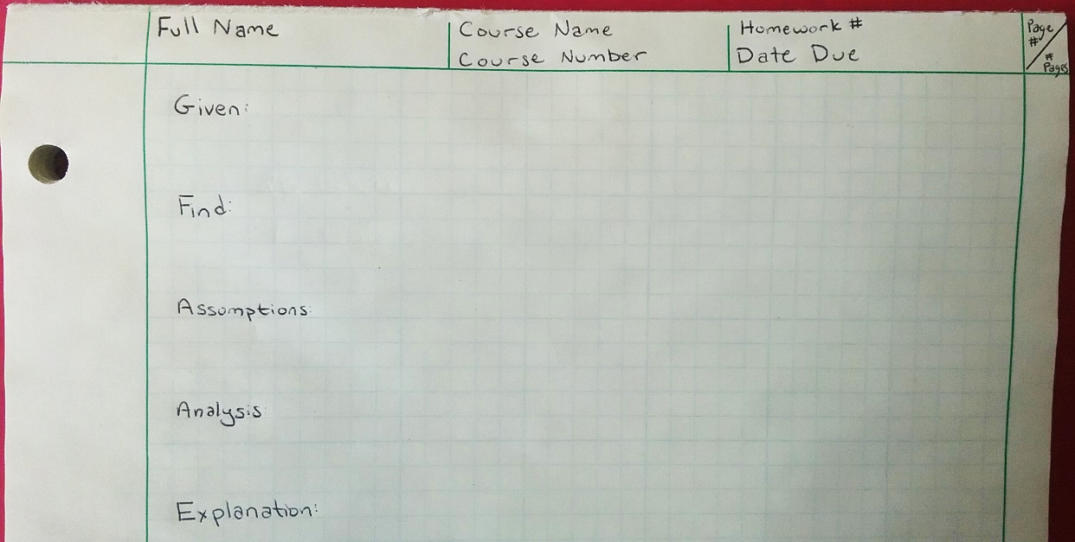
Figure 1 – Problem Set Format
Grading Scheme (subject to change):

Problem Sets | 15% | 7 total (8-1 dropped)
Exams | 60%
Team Based Problems (including HOLD) | 15%
Participation | 10%
 | 100%

Team Based Problems (TBPs):
You will have three (3) team based problems assigned during the term. This is your opportunity to think about how the concepts in this class can be applied to the world around you. For each of these problems, be creative, have fun, learn about the things that inspire you!
Hands On Learning Day (HOLD):
You will have short assignments related to the activities performed on HOLD days.
TBPs + HOLD = 8 assignments = 15% of your grade
Problem Set Grading Rubric:
There is a total potential of 20 points for each problem set.

Completeness: Each problem was thoroughly attempted and significant progress was made | $$8*\frac{Number Completed}{Number Assigned}$$
Clarity of Concepts:  Solutions begin with a conceptual framework and demonstrate conceptual understanding of the fundamentals | 3  All solutions demonstrate clarity of concepts | 2  The majority of solutions demonstrate clarity of concepts | 1  Some solutions demonstrate clarity of concepts | 0  No solutions demonstrate clarity of concepts
Correctness | 6  All solutions are completely correct | 4  There are minor errors in the solutions | 2  There are major errors in the solutions | 0  There are no correct answers
Formatting:  Proper formatting is used, neat, easy to follow | 3  Proper formatting is used and problem sets are neat | 2  There are some formatting or neatness errors | 1  There are major formatting or neatness errors or the solution cannot be followed | 0  No formatting requirements are met

"Academic Honesty Policy." WPI: University Policies:. N.p., n.d.
On September 23, 1999 NASA lost the $125 million Mars Climate Orbiter spacecraft after a 286-day journey to Mars. Miscalculations due to the use of English units instead of metric units apparently sent the craft slowly off course -- 60 miles in all. Thrusters used to help point the spacecraft had, over the course of months, been fired incorrectly because data used to control the wheels were calculated in incorrect units. Lockheed Martin, which was performing the calculations, was sending thruster data in English units (pounds) to NASA, while NASA's navigation team was expecting metric units (Newtons). On January 26, 2004 at Tokyo Disneyland's Space Mountain, an axle broke on a roller coaster train mid-ride, causing it to derail. The cause was a part being the wrong size due to a conversion of the master plans in 1995 from English units to Metric units. In 2002, new axles were mistakenly ordered using the pre-1995 English specifications instead of the current Metric specifications.

