Aerospace Junior Design
Written Assignment: Capstone Project Ideas
MOTIVATION/ BACKGROUND FOR ASSIGNMENT:
Students have an opportunity to propose ideas for capstone projects and have input on which topics are selected for Aerospace Capstone Design.
Engineering design begins with identifying and meeting a need. To create value, you need to understand the people who would use your product. In class, the "Value Proposition Canvas" (figure 1) was described as one way to look at the fit between a product and its customers.
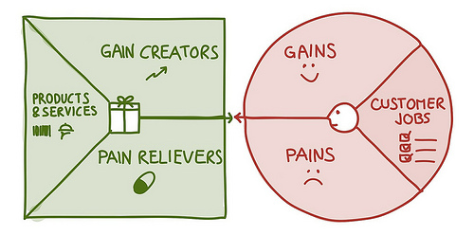
Figure 1: Value Proposition Canvas by Strategyzer

WRITING ASSIGNMENT
For full credit, you must identify at least 3 sources of information that you used to complete the assignment. They can either be interviews with a faculty or staff member, web sites, books, or articles. Include citations for written material (format isn't critical); identify interviewee and date of interview.
Part 1: Describe the Project idea.
1a. Describe an idea that you think might be a good Aerospace Capstone Design project. You may add photos from relevant websites.
1b. What do you like about this idea?
1c. What do you think is the biggest challenge to implementing this idea?
1d. If time permits, would you or a friend like to present your idea to the class? NOTE: If several students are interested in the same topic, they are encouraged to present as a group.

Part 2: Consider Potential Customers.
2a. Describe a potential customer of this product. Where does he or she work and what are his/her jobs? You may add links to relevant websites if you wish.
2b. Describe one or more specific features of this product that would help customers do their jobs, reduce problems or "pains", or provide benefits or "gains".

ASSIGNMENT GRADING CRITERIA:
- Were at least 3 sources of information used to complete the assignment?
- Compliance with the tasking (did you answer all questions asked?)
- Reasonable effort- and document is spell checked & edited. [Try reading it aloud!]
- Proper submission format (Word or PDF uploaded to CANVAS, 11 point font or larger)

Note: All students must complete this writing assignment,
but students are not required to brief their ideas to the class.

https://strategyzer.com/canvas/value-proposition-canvas. Accessed 1/4/2018

