Individual Project
Peer Review Instructions

Peer Review Process
- Watch this Canvas tutorial video to learn how to add comments to a submissions, submit peer review, and view peer review feedback on your own assignment.
- You must leave at least one comment for Canvas to consider your peer review completed.
- You should prepare a review report, typically half a page to two pages, summarizing your review comments.
- Upload your peer review report
- through the IP D2 peer review as an attachment (see figure below). This allows your fellow students to see your review report.
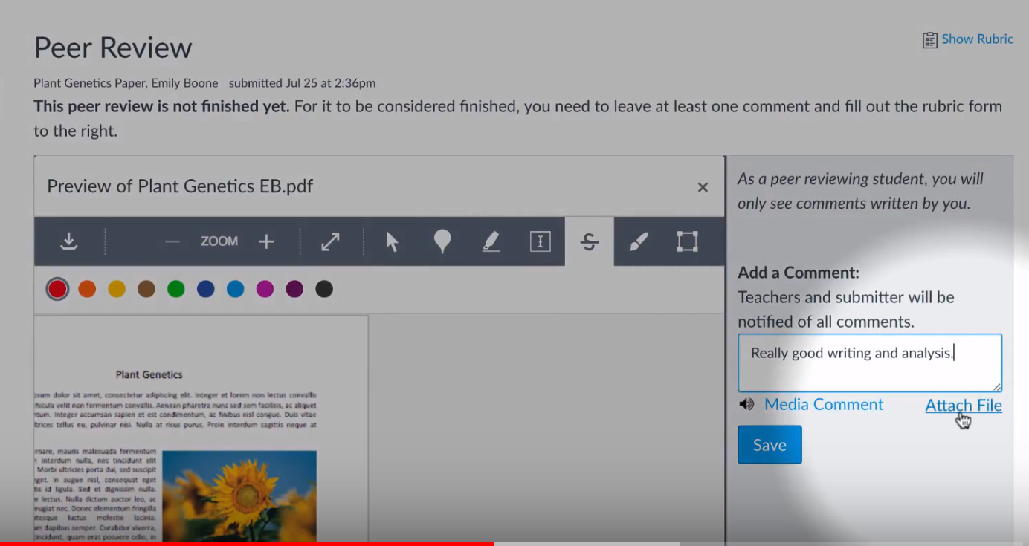
AND
- through the IP D3 submission portal. This allows the teaching team to grade your peer review report.

Peer Review Report Guidelines
The reviews should be informed by the grading rubric for D2 and D4 (see Canvas). However, your task as a peer reviewer is not to “grade” the project (i.e., there is no need to provide a numerical score for each rubric area). The task of the peer reviewer is to write comments for each of the four main areas. Your main role as reviewer is to provide feedback on the report.
The best feedback will promote actions on the part of the author to improve the report. As such, subjective comments on quality (like “this is great” or “this is not great”) are not that helpful. Comments that give specific suggestions or specific direction are better. As you write your comments put yourself in the author’s position of needing to read those comments and actually do something about it. Are you making implementable suggestions or are you asking the impossible? Do unto others as you would have them do unto you!
The peer reviews do not have to be long to meet a satisfactory level for peer review. Quality of comments always trumps quantity. However, if you only have a few sentences, then the likelihood that you have achieved high quality is not very high. You should try to write at least a few sentences on each of the four main areas (report writing, technical: synthesis, technical: exploration, technical: addressing feedback).

Grading Rubric for Peer Review Report
 | General Review Quality (80%) | Suspends Initial Judgement (20%)  (for Questions #6 and #7)  [EM@FSE2.0 d]
Excellent | (4/4) Review is extensive and covers all of the main areas and some of the sub-areas, too. The comments are primarily actionable. | (5/4) Review demonstrates strong critical thinking and analytical skills through well thought-out comments regarding the author’s arguments about questions #6 and #7. The review does not immediately agree or disagree with the ideas without sound reasoning. The review provides meaningful, constructive feedback to help the author revise the proposed ideas and improve her arguments for the ideas.
Good | (3/4) Review is brief (e.g., a paragraph) but covers all four of the main areas. The review as multiple actionable comments. | (3/4) Review demonstrates critical thinking regarding the author’s arguments about questions #6 and #7, and provides meaningful, constructive feedback.
Satisfactory | (2/4) Review is brief (e.g., a paragraph) but covers all four of the main areas. The review includes at least some actionable comments. | (2/4) Review demonstrates some critical thinking regarding the author’s arguments about questions #6 and #7.
Below  expectations | (1/4) Review is very brief (e.g., one or two sentences) or contains primarily qualitative “cheerleading” judgements (i.e., ‘good’ or ‘bad’). | (1/4) Review is mostly “cheerleading” or absolute dismissal of the author’s ideas, and does not demonstrate critical thinking regarding the author’s arguments about questions #6 and #7.
Not acceptable | (0/4) Review is missing or largely irrelevant. | (0/4) Review is missing or largely irrelevant.

