Ohio Northern University
ECCS Department
Fall Semester 2018

ECCS 2311 Electric Circuits, Section 3
Instructor: Dr. Heath J. LeBlanc
Course Coordinator: Dr. Heath J. LeBlanc
Office: BI 247

Contact Information:
Office Phone: 419-772-2389
Email: h-leblanc@onu.edu

Class Information:
Class / Lab Location: BI 238 / BI 219
Class Time: MWF 8:00-8:50am
Lab Time: Tuesday 8:00-10:45am
Office Hours:
M: 10-11 & 1-2
T: 3-4, W: 2-3
F: 11-12

Catalog Data: 4.00 Credits – DC and AC circuits. Basic laws, analysis techniques, and circuit theorems. Op amps, first-order circuits, sinusoids and phasors, ac power analysis, ideal transformers and three phase circuits. Computer simulation. Integrated laboratory experience.
Offered fall semester.
Prerequisite: MATH 1631 or MATH 1621.

Textbook: Khalid Al-Olimat, “Electric Circuits Analysis”, Linus Learning, 2018.
Lab Manual: Khalid Al-Olimat, “ECCS 2311 Electric Circuits Lab Manual”, ONU Bookstore.
Software Package: PSPICE
Course Website: Moodle: http://northernonline.onu.edu or http://northernonline.onu.edu/my (requires login). Syllabus, schedule, course notes, and other information will be posted on Moodle.

Class Rules:
Lecture: The best way to keep up with the material of the class is by attending class. If you need to miss class for any reason, please let the instructor know ahead of time.

Laboratory: Laboratory attendance and participation is mandatory. If you need to miss a lab for any reason, the instructor must be notified immediately so you can attend a lab of a different section for that week. No student will be granted a passing letter grade unless ALL labs are submitted! The first 10-15 minutes of lab will be devoted to the weekly quizzes, and there will be different assignments due in
the lab (see the schedule for the specific list). In the last week of lab there will be a lab final that will be an individual test for each student on working with the lab equipment and/or PSPICE, so be sure you understand all that is done in the lab!

Homework: Homework is collected at the beginning of class. Homework assigned in one class is due the next class period. No late homework is accepted. Please keep up with the homework assignments in order to be successful in the course. See the schedule posted on moodle for assigned homework! It is recommended that students also work through the problems in the book that are not assigned, and the answers to all problems are available at the back of the book. Circuit analysis requires a lot of practice to master the techniques! Additional supplemental problems and their solutions are posted on moodle.

Teamwork: Helping a fellow student understand material from the class is encouraged and applauded. However, assignments are supposed to be a metric for assessment of the individual student’s effort. Group assignments, such as laboratory experiments and the design project, should be done in collaboration.

Course Activities and Assignments:
- In-Class Group Problems: Engineering requires collaboration; hence circuit analysis problems will regularly be worked in small groups (two to three students) to promote peer learning and teaching, as well as give an opportunity in class to reinforce key circuit concepts.
- Quizzes: There will be weekly quizzes held at the beginning of lab taken from end-of-chapter problems in the textbook. These quizzes serve as technical checkpoints to ensure each student is truly understanding the homework problems and learning the circuit analysis techniques of the course.
- Midterm Exams: There will be two midterm exams during the semester as major technical checkpoints.
- Laboratory Experiments and Lab Final: Many of the key concepts of the course will be explored through laboratory experiments. To ensure each student becomes proficient at using the lab equipment and PSPICE, there will be an individual lab final the last week of lab.
- Question Submissions: Question formulation is a critical life skill, as it links us to which is unknown to us and opens it up for exploration. There will be 3 question submissions throughout the semester, due in lab, and each student must compose at least 3 questions that are relevant to the material covered previously in the course up to the prior question set submitted (e.g., the 2nd question set should cover material after the 1st question set was submitted). The questions should be formulated so as to have a high propensity for exploration so they would serve as good research questions to explore. Hence, the questions will be graded on grammatical correctness, clarity, readiness or topic orientation, potential of depth of exploration, and relevance to the portion of the course covered. Example questions that meet these criteria will be given to students by the instructor throughout the semester to aid in developing the skill of question formulation.
- Circuit Research Question Exploration: One or more questions should be articulated by each student to serve as a guide for an exploration into an electric circuits-related topic. The exploration report should be 2-4 pages in length and should have at least one peer-reviewed citation (book other than the course textbook, journal article, conference paper, etc.). In this case, the research question(s) need not be restricted to topics covered in this course but should be somehow related to electric circuits. More details will be provided in an assignment handout.
- Circuit Analogy Reflection: Throughout the course, many analogies will be shared with students to help connect electric circuit concepts to real life experiences as well as other, more familiar, topics. In Week 12 in lab, students must submit a ½ to 1-page analogy reflection. In the assignment, students must either reflect on one of the analogies given throughout the course to connect it to a personal life experience, or to create their own analogy that connects the circuit content to a life experience or other topic.
- Design Project: The circuit design project aims to improve students’ ability to follow the engineering design process, apply circuit analysis techniques, select circuit components from circuit suppliers, identify appropriate circuit distributors, implement and test circuits, work collaboratively in diverse groups, and articulate a value proposition using the Need-Approach-Benefits-Competition (NABC) idea formulation technique. Deliverables include a design alternatives document (submitted individually), problem (needs) framing, and final written report.

Course Outcomes:
Upon completion of this course, the student should be able to:

- Solve DC electric circuits as well as single and three-phase circuit problems through use of basic circuit laws, analysis techniques, and network theorems.
- Solve circuit problems containing operational amplifiers.
- Apply fundamental principles of storage elements to solve first-order transient circuit problems.
- Determine the capacitance required for power factor correction in both single-phase and three-phase loads.
- Analyze ideal transformer circuits.
- Design and construct simple circuits based on given specifications.
- Use PSPICE software to analyze electric circuits.
- Demonstrate competence in both safely constructing electric circuits and obtaining experimental data through laboratory work.
- Connect life experiences with circuit content and recognize and explore circuit knowledge gaps as curious learners who take ownership of their learning through question formulation and questioning information given without sufficient justification.
- Explore multiple solution paths in the circuit design process by gathering experimental and simulation data to support or refute circuit design ideas, identifying and evaluating relevant sources of information, considering the underlying problem from multiple viewpoints, and demonstrating an understanding of the ramifications of circuit design decisions, ultimately to craft a compelling value proposition tailored to specific stakeholders about circuit solutions that meet stakeholder needs.
- Teach and learn from peers while meeting project and team commitments, developing an appreciation of hard work, recognizing the benefits of focused and fervent effort, accepting responsibility for their own actions, crediting the actions of others, and identifying and working with individuals with complementary skill sets, expertise, etc., in order to produce effective written reports and verbal presentations that incorporate instructor feedback and present technical information effectively (graphs, tables, equations).

Grading:
Homework: 10%
Quizzes: 10%
Laboratory Experiments & Lab Final: 10%
Design Project: 5%
Entrepreneurially Minded Learning (EML) Assignments: 5%
Midterm Exams (15% each): 30%
Final Exam: 30%
All exams are closed book and notes.
A: 90-100, B: 80-89, C: 70-79, D: 60-69 and below 60 is F.

Course Schedule: The following is an outline of the schedule; a more detailed schedule is provided separately:
Week 1: SI units, electric charge, current, voltage, power, resistance, Ohm’s Law, conductance
Week 2: KVL, KCL, equivalent resistance, voltage division, current division
Week 3: Labor Day Holiday, Nodal analysis, mesh/loop analysis, Question Set 1
Week 4: Mesh analysis, linearity, superposition, source transformation, Thevenin/Norton’s Theorems,
Week 5: Thevenin’s Theorem with dependent sources, max DC power transfer, op amp circuit analysis
Week 6: Exam 1, design of op amp circuits, Question Set 2
Week 7: Design Project Assigned, Capacitors & Inductors, RC transient analysis
Week 8: Fall Break Holiday, RC & RL transient analysis
Week 9: Sinusoids, complex numbers and phasors, Circuit Research Exploration Due
Week 10: Reactance, Impedance, Admittance, Exam 2, Question Set 3
Week 11: Steady-state AC analysis, Design Alternatives Due, Instantaneous & average AC power
Week 12: RMS values, Max average power transfer, complex power, Analogy Reflection
Week 13: complex power conservation, pf correction, 3-phase intro, Balanced Y-Y, Design Project Lab
Week 14: Analysis of balanced 3-phase systems and power, Design Project Report Due
Week 15: Ideal transformers, dot convention, reflected impedance, Project Demos, Lab Final
Final Exam: Wednesday, December 12, from 7:00am–9:00am in Biggs 238

ONU Academic Honesty Policy:
The University expects its students to conduct themselves in a dignified and honorable manner as mature members of the academic community and assumes that individually and collectively they will discourage acts of academic dishonesty. The University also expects cooperation among administrators, faculty, staff, and students in preventing acts of academic dishonesty, in detecting such acts, reporting them, and identifying those who commit them, and in providing appropriate punishment for offenders. The University Code of Academic Student Conduct is found in Appendix C of the Student Handbook.

Special Accommodations Policy:
Students requiring particular accommodations because of physical and/or learning disabilities should contact their Dean’s office prior to or during the first week of classes. For additional information, see: http://www.onu.edu/student_life/disability_services

Title IX Information:
Ohio Northern University does not discriminate or tolerate discrimination on the basis of sex, gender, transgender status, gender identity, or gender expression in its educational, extracurricular, or athletic programs, or in any admission or employment decisions. ONU is committed to promptly and equitably responding to all reports of sexual discrimination with the goal of eliminating the misconduct and/or harassment, preventing its recurrence, and addressing its effects on any individual or the community.
To report sexual misconduct (violence) or sexual harassment, students may contact the Title IX Coordinator,
Nancy Sabol, (419) 772-2218, n-sabol@onu.edu or one of the Deputy Title IX Coordinators, Brian Hofman,
(419) 772-1878,b-hofman@onu.edu; LaShonda Gurley, (419) 772-3145, l-gurley@onu.edu.
To confidentially discuss sexual misconduct (violence) or sexual harassment, students may contact University confidential Resources: Counseling Center, (419) 772-2190; Health Center, (419) 772-2086; or Chaplain,
(419) 772-2200. For more information, the University's Sexual Discrimination Policy is available at www.onu.edu/title_IX.
Course Organization: The course is organized into modules, each of which has specific learning objectives.
- Module 1: Electric Circuit Analysis Fundamentals
  - Electric charge, current, voltage, power, passive sign convention, resistors and Ohm’s Law, conductance, KVL, KCL, series & parallel topologies, equivalent resistance, voltage division, current division.
Upon completion of this module, the student should be able to:
- Explain in his or her own words accurately the meaning of electric charge, current, and voltage.
- Interpret and illustrate the passive sign convention in circuit analysis.
- Calculate power absorbed or supplied by a circuit element
- Demonstrate power balance in circuits.
- Explain in his or her own words accurately the meaning of resistance and conductance.
- Apply Ohm’s Law to determine the voltage across or current through a resistor.
- Identify series-connected & parallel-connected circuit elements along with branches, nodes, & independent loops.
- Apply KVL and voltage division to circuit analysis
- Apply KCL and current division to circuit analysis
- Simplify resistive networks using series and parallel resistance equivalence rules.
- Module 2: DC Analysis at Steady State
  - Nodal, mesh/loop, linearity & superposition, source transformation, Thevenin’s Theorem, Norton’s Theorem, max DC power transfer.
Upon completion of this module, the student should be able to:
- Apply nodal analysis in circuits consisting of resistors and ideal independent/dependent, voltage/current sources.
- Apply mesh analysis in circuits consisting of resistors and ideal independent/dependent, voltage/current sources.
- Identify the defining properties of linearity applied to linear circuits.
- Analyze DC circuits with multiple independent sources using the principle of superposition.
- Analyze a circuit using source transformation.
- Analyze a linear DC circuit using Thevenin’s Theorem and obtain the Thevenin equivalent circuit between two nodes of the circuit.
- Apply the maximum power transfer theorem to determine the optimal load for a given DC circuit (for max power transferred to the load).
- Module 3: Operational Amplifiers (Op Amps)
  - Input-output voltage characteristics, non-ideal op amps, ideal op amp assumptions, voltage supply effects, op amp configurations, and mathematical transformations implemented using op amp circuits.
Upon completion of this module, the student should be able to:
- Analyze circuits containing operational amplifiers
- Identify different op amp configurations within a complex op amp circuit
- Illustrate and distinguish between the input-output voltage characteristic of an ideal and non-ideal op amp.
- Design op amp circuits to implement mathematical transformations for signal conditioning.
- Appraise and critique the effects of supply voltage on the behavior of an op amp circuit.
- Module 4: First-Order Circuit Elements and Dynamic Response Analysis
  - Capacitors, inductors, RC and RL transient behavior, and general first-order transient analysis.
Upon completion of this module, the student should be able to:
- Simplify capacitive networks using series and parallel capacitance equivalence rules.
- Simplify inductive networks using series and parallel inductance equivalence rules.
- Determine the transient response of a voltage or current signal in a circuit containing a single independent inductor and DC sources.
- Determine the transient response of a voltage or current signal in a circuit containing a single independent capacitor and DC sources.
- Explain in his or her own words the functionality of a capacitor and describe at least one application of a capacitor.
- Explain in his or her own words the functionality of an inductor and describe at least one application of an inductor.
- Module 5: AC Steady-State Analysis
  - Sinusoids, complex numbers, phasors, impedance, admittance, rms value, nodal, mesh/loop, superposition, Thevenin/Norton’s Theorems, max average AC power transfer, complex power, power factor correction, ideal transformers.
Upon completion of this module, the student should be able to:
- Determine the frequency, phase shift, and amplitude of a sinusoid given a graphical or mathematical representation of the sinusoidal signal.
- Quantitatively and qualitatively compare phase shifts between sinusoids at the same frequency.
- Convert complex numbers represented in rectangular form to polar form and vice versa
- Recite Euler’s Equation from memory
- Transform a sinusoid into its phasor representation and vice versa.
- Relate the integral and derivative of a sinusoidal signal to its equivalent representation in the phasor domain
- Calculate the impedance of a network consisting of capacitors, inductors, and resistors as a function of the frequency of the voltage and current signals.
- Determine the impedance or admittance of an individual resistor, capacitor, and inductor given the frequency of operation.
- Determine the admittance of a network given the impedance, and vice versa.
- Recite KVL and KCL for phasors.
- Use Voltage Division and Current Division in steady-state AC circuit analysis.
- Apply nodal analysis to steady-state AC circuits.
- Apply mesh analysis to steady-state AC circuits.
- Simplify impedance networks using series and parallel equivalence rules
- Analyze steady-state AC circuits with multiple independent sources at different frequencies using superposition
- Analyze a linear AC circuit using Thevenin’s Theorem and obtain the Thevenin equivalent circuit between two nodes of the circuit.
- Calculate the average and instantaneous power absorbed by any circuit element in an AC circuit.
- Apply maximum average power transfer theorem to determine the optimal load impedance for a given AC circuit (to determine max average power transferred to the load).
- Calculate the rms (effective) value of a periodic signal.
- Illustrate the power triangle and explain its relation to complex power, average power, reactive power, apparent power, and power factor.
- Use Conservation of AC Power to infer voltage and current values in a circuit given the complex power absorbed by loads in the circuit.
- Determine the capacitance required for power factor correction in a single phase inductive load.
- Recite the ideal transformer equations.
- Apply the dot convention to determine the sign of the ideal transformer equations.
- Analyze ideal transformer circuits to determine a voltage or current within the circuit.
- Determine the reflected impedance of either primary to secondary or secondary to primary due to an ideal transformer and apply it to the analysis of ideal transformer circuits.
- Module 6: Polyphase Circuits
  - Phase sequence, balanced source and loads, Y-Y, Y-Δ, Δ-Y, and Δ-Δ balanced, 3-phase configurations and analysis, power in balanced, 3-phase systems.
Upon completion of this module, the student should be able to:
- Transform a balanced 3-phase load between Y and Δ connection.
- Transform a balanced 3-phase source between Y and Δ connection.
- Relate phase and line voltages and currents.
- Determine the phase sequence of a set of 3-phase voltages
- Identify and distinguish between the four different combinations of source and load connections in a 3-phase circuit (Y-Y, Y-Δ, Δ-Δ, and Δ-Y).
- Analyze a balanced Y-Y, 3-phase circuit.
- Analyze a balanced Y-Δ, 3-phase circuit.
- Analyze a balanced Δ-Y, 3-phase circuit.
- Analyze a balanced Δ-Δ, 3-phase circuit.
- Analyze complex power and power factor in balanced 3-phase circuits.
Course Diagram: Below is a mind map for the overall course showing how the modules fit into the overall course.

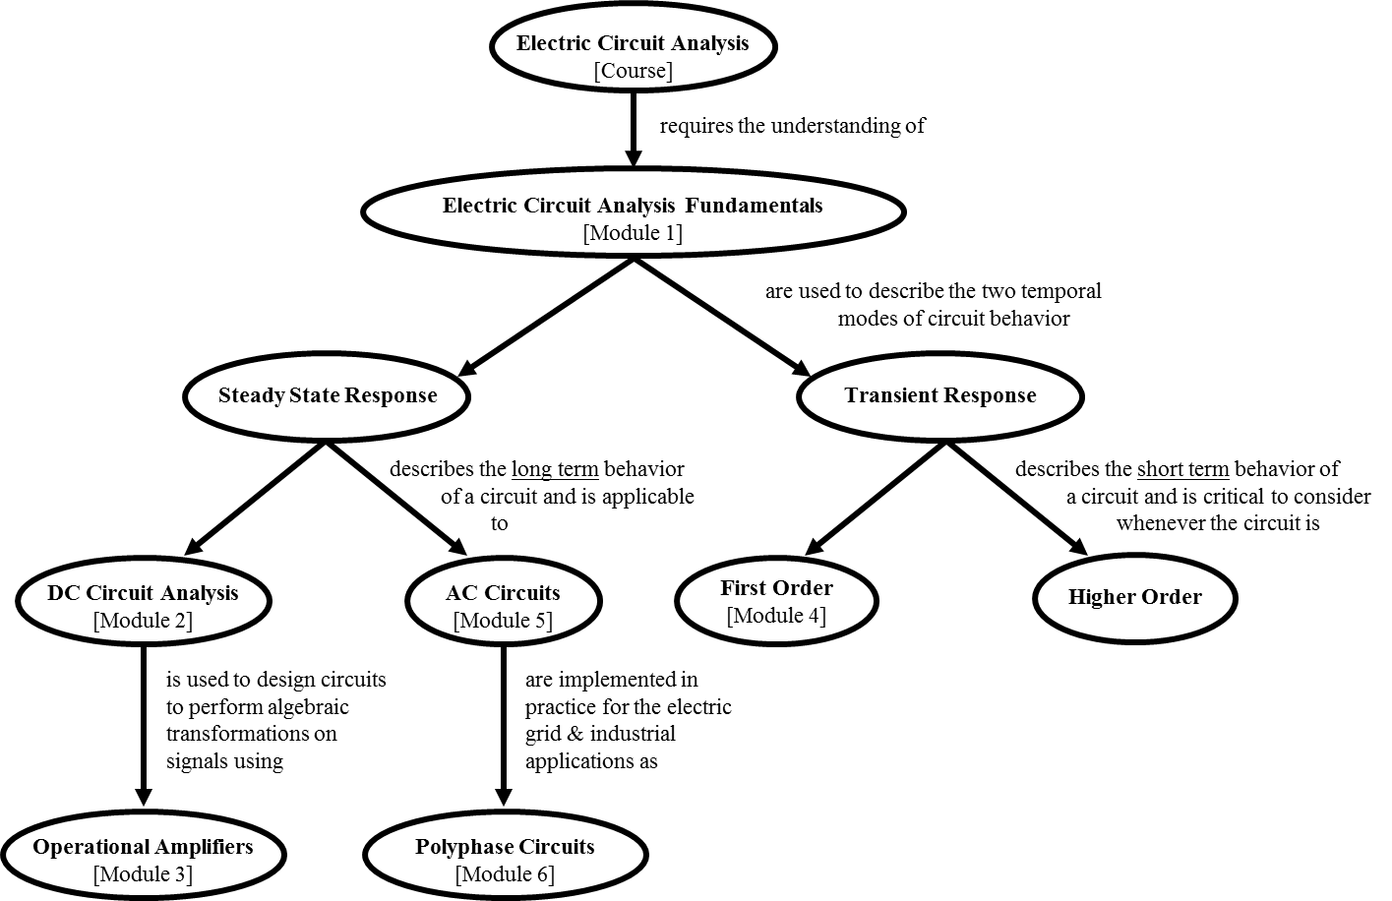

Study abroad:
Skills in another language, cross-cultural experience, adaptability, and creative problem solving are extremely valuable for students seeking employment in almost every field, you can gain experience in all of these by studying abroad. It is affordable, credits earned abroad transfer back and count toward graduation, study abroad -- especially in a non-English-speaking country -- looks great on your résumé and gives you a unique perspective to bring to job interviews. For more information contact
Alyssa Bell, Study Abroad Coordinator (a-bell.1@onu.edu, 122 Lehr Memorial, 772-3156).
Website: http://www.onu.edu/studyabroad - Facebook: ONUstudyabroad - Twitter: @ONUstudyabroad.

Campus Emergencies:
In the event of a campus emergency, including weather emergencies, consult the campus homepage (www.onu.edu) and/or WONB radio (94.9 FM) for information. If a class is cancelled for reasons other than campus or weather emergencies, an announcement will either be made in class or sent via onu.edu e-mail by your instructor.

