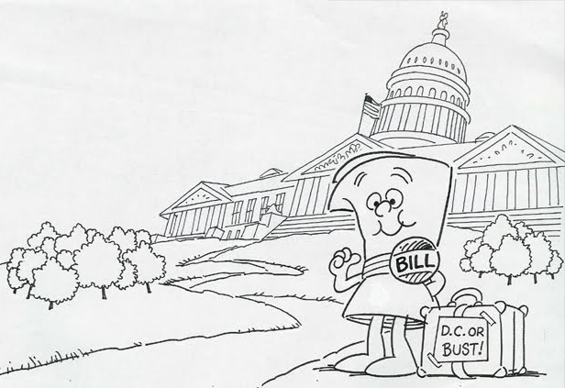
Energy Efficiency
Legislation

“The War on Fossil Fuel Initiative!”
All fossil fuel based power plants utilizing rivers as a cooling system will be fined an additional 1,500,000,000 Watsons per year. Please include this new fine in your yearly fiscal analysis.

All fossil fuel based power plants utilizing cooling towers as a cooling system will be fined an additional 1,200,000 Watsons per year. Please include this new fine in your yearly fiscal analysis.

“Department of Energy Revolution for an Alternative Solution”
All power plants utilizing solar technology will receive a government issued rebate. This one time rebate will total 30% of the total power plant installation cost.

All power plants utilizing wind technology will receive a government issued rebate. This one time rebate will total 15% of the total power plant installation cost.

The Better Better Building Initiative
Any power plant intended to be built within the great state of NY must have a cycle thermal efficiency of at least 30%, and a plant efficiency of at least 15% to be a viable candidate.

“Springfield Enabling Energy Savings Innovations Act”

In the interest of promoting nuclear power generation to reduce harmful emissions, the nuclear waste storage fee has been reduced to 30,000 Watsons/ton to be paid on a bi-monthly basis.

As a result of failed research attempts for cleaner burning fossil fuels, the environmental fines attributed to the use of these fuel types have greatly increased.

