Thrust
Internal Combustion Engines
The first aircraft engine, the Wright Engine, was created by the first aviation mechanic, Charles E Taylor (Figure 98). This type of engine is called an internal combustion engine and can be found in cars, lawnmowers, trucks, and many other practical machines. All of these machines serve very different purposes, but the function of the internal combustion engines that powers them
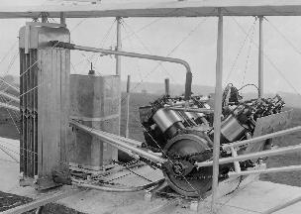
Figure 98. Wright Engine (source: class PPT)
is essentially the same. This type of engine is a four-stroke engine where the piston completes four separate strokes—intake, compression, power, and exhaust. The internal combustion engine completes this thermodynamic cycle with two revolutions of the crankshaft. This crankshaft is located inside the engine block along with the attached piston rods and pistons. As the crankshaft turns, the lifter causes each piston to move up and down. On the top, there is a camshaft that is attached to the crankshaft with a belt. The camshaft turns and opens/closes the valves while the crankshaft moves the pistons. The four strokes of an internal combustion engine are illustrated below in Figure 99.
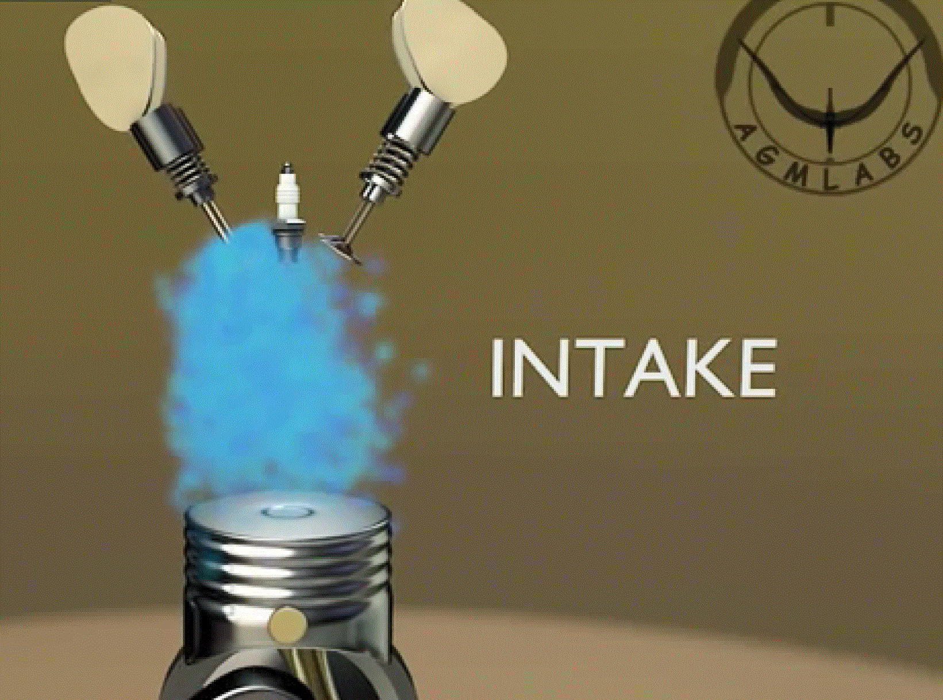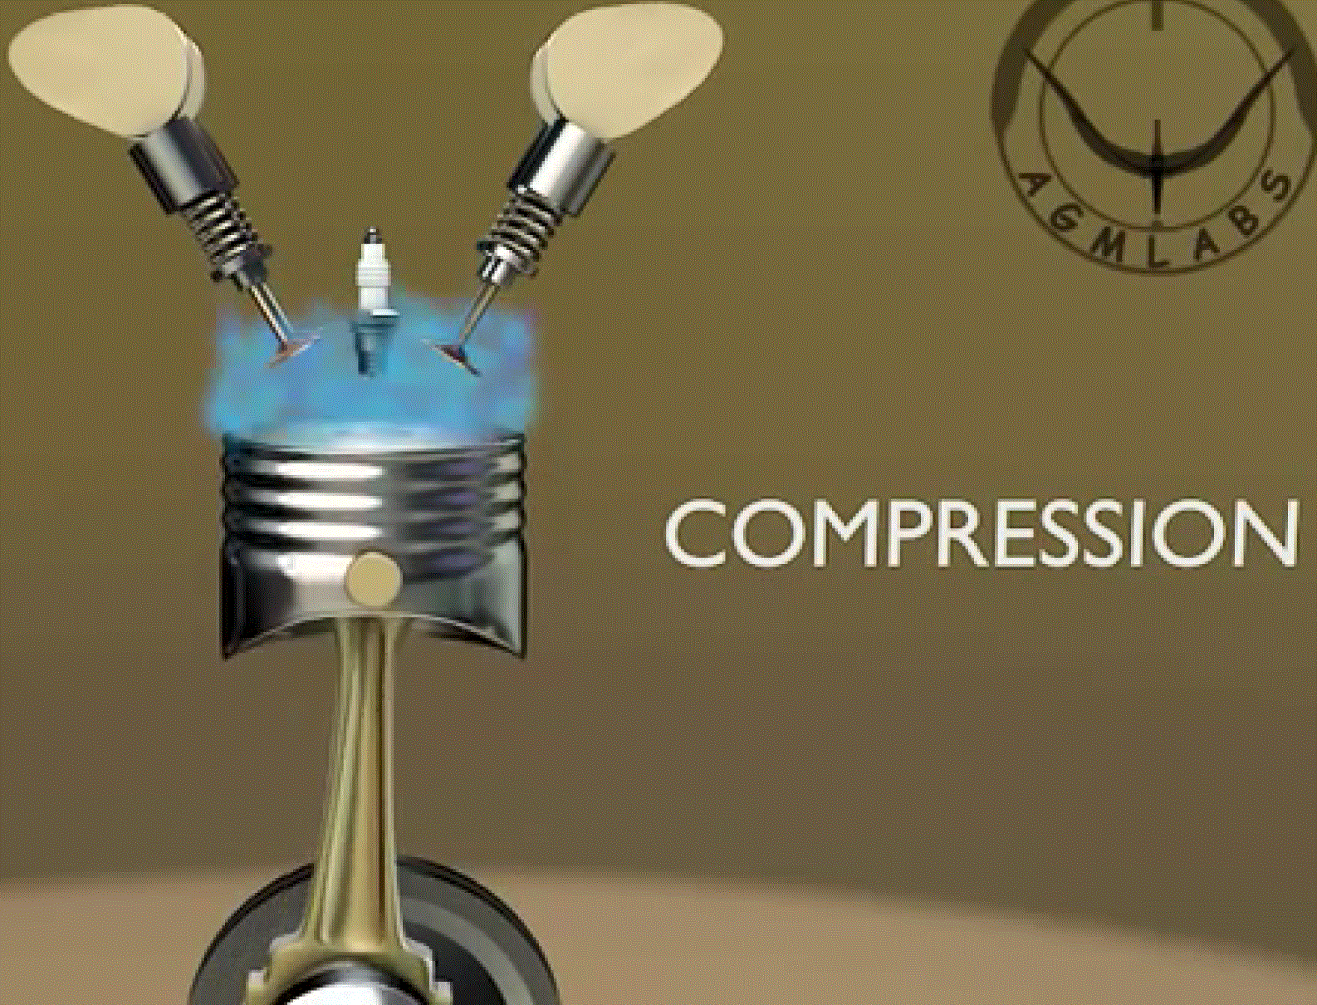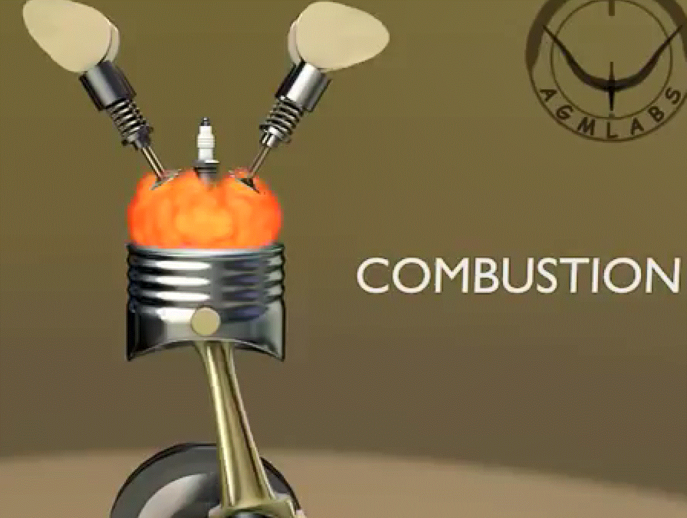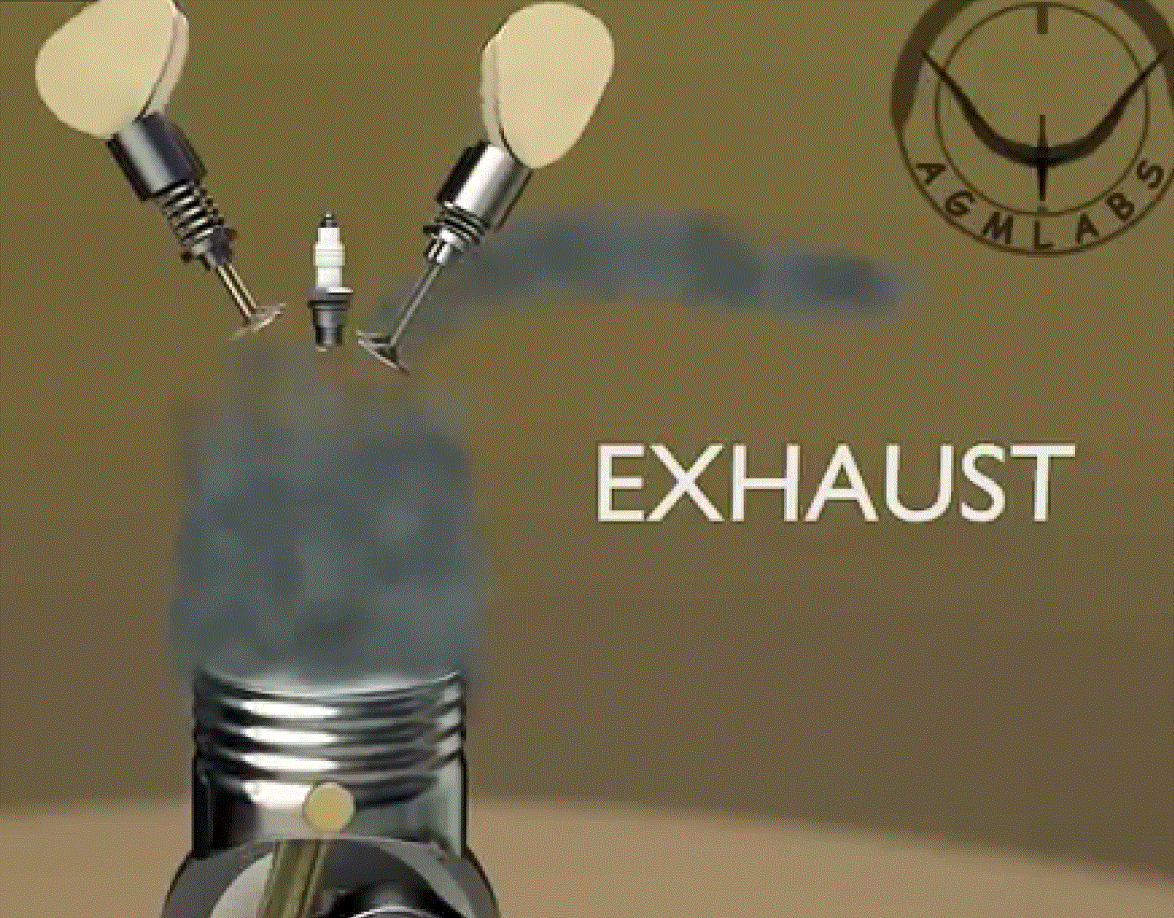
A
B
C
D
Figure 99. Four strokes of an internal combustion engine (source: class PPT)
Figure 99-a depicts the intake stroke. In this step, the inlet valve opens and the fuel-air mixture is taken in as the piston moves down. Then, in Figure 99-b, the inlet valve closes and the piston travels back up, compressing the fuel-air mixture. This step is known as the compression stroke. Third, Figure 99-c shows the fuel-air mixture combusting after a spark plug emits a spark. The pressure from this combustion forces the piston down in a stroke known as combustion stroke. Lastly, Figure 99-d demonstrates the exhaust stroke. In this final stage, the exhaust is expelled as the exhaust valve opens and the piston moves up to expel the gases. At the top of this stroke, the exhaust valve is closed. This process continually repeats and this is where the engine power is derived. Though this figure only shows one cylinder, there are typically two or more cylinders working in unison to produce power.

Otto Cycle
An Otto cycle is an idealized cycle that further explains how an internal combustion engine (such as the one in Figure 99) functions. As a gas encounters changes in pressure, volume, temperature and a removal and addition of heat, the Otto cycle describes what happens with these changes; ultimately, enough work will be produced to create enough thrust to propel a machine. The pressure-volume diagram of an Ideal Otto Cycle is pictured below (Figure 100).
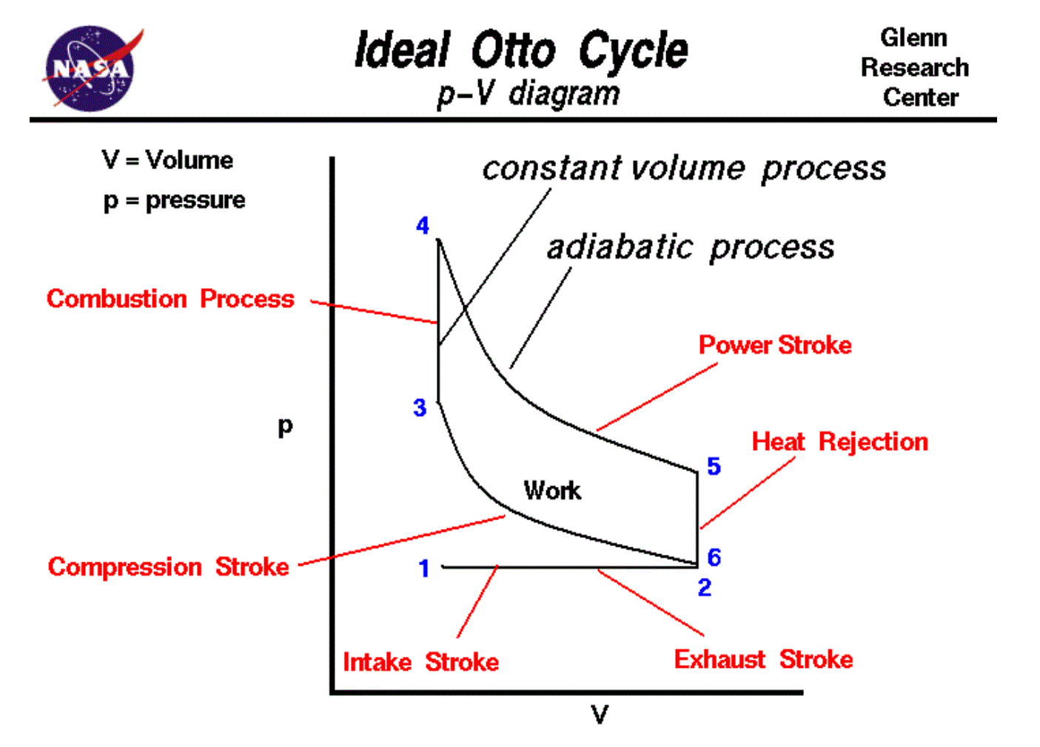
Figure 100. Ideal Otto cycle https://www.grc.nasa.gov/www/k-12/airplane/otto.html
The intake stroke is shown in the lower left by the blue number one. At the beginning of this stroke, the gas’s volume is as small as it will be and the pressure is close to atmospheric pressure. When the intake valve opens (between the blue numbers one and two), the volume of the gas increases as the fuel-air mixture flows into the cylinder while the pressure remains the same. The number two marks the beginning of the compression stroke. The intake valve closes, and the volume of the gas decreases as the piston moves back up. Since work is done on the gas by the piston, pressure increases as shown by the curve (Glenn Research Center). The blue number three is when the combustion stroke begins. The volume of the gas remains constant during this stage, but since heat is released, pressure increases along with temperature. Then, at the number four, the power stroke starts. During this stroke, the volume of the gas increases as the piston travels downward and pressure decreases as the gas does work on the piston. The number five marks when the exhaust valve opens. During this stage, volume stays the same and pressure returns to the atmospheric condition since the remaining heat is transferred with the surroundings. As mentioned in the previous section, this cycle will repeat itself over and over again to produce power. The area enclosed by this pressure-volume curve is the difference between work done by the gas and work done on the gas (Glenn Research Center). This is clear since the piston does work on the gas between the numbers two and three, and the gas does work on the piston between the numbers four and five.

Thrust Equation
An important question to consider is what exactly creates thrust. We know that the engine produces power to power a propeller to propel the aircraft forward, but what is causing this thrust and how? As we will see, a pressure difference and velocity difference are what ultimately create thrust.
First, we considered the law of conservation of mass. In the form of an equation, $\frac{d}{dt}\iiint{ρ⋅d∀}+∯{ρV⋅ds}=0$. The first term in this equation represents the change in mass over time inside the control volume. This is made clear when analyzing the units of each variable: $ρ=\frac{kg}{m^{3}}, ∀=m^{3}$. When these two are multiplied, the integrand has final units of kilograms. So, the whole first term is simply the change in mass multiplied by $\frac{d}{dt}$, the change in time. The second term in this equmation represents the rate of mass flow in and out of a control volume, or mass flux. Doing similar unit analysis, $ρ=\frac{kg}{m^{3}}, V=\frac{m}{s}, ds=m^{2}$. When these three are multiplied, we are left with $\frac{kg}{s}$, the same units as the first term. The difference between these two terms is that the second one involves area. This term refers to the flow in and out of a control volume, not just the change in mass over time. Since these two terms are equal to zero, this means that the two terms equalize each other, so the rate of mass flow in/out of a control volume makes up for any change in mass over time.
Next, we looked at the law of conservation of momentum. This can be represented mathematically by $\frac{d}{dt}∰{ρV⋅d∀}+∯{\left(ρV⋅ds\right)V}=F_{pressure}+F_{gravity}+F_{D(viscous)}$. The first term of this equation has units of $ρ=\frac{kg}{m^{3}}, V=\frac{m}{s}, d∀=m^{3}$. When these units are multiplied together, we obtain $kg(m)$ over a unit of time, or the change in momentum over time. This term is similar to the first term of the law of conservation of mass; however, now we are considering momentum just momentum because it is nothing but mass*velocity rather than just mass. The second term has units of $ρ=\frac{kg}{m^{3}}, V=\frac{m}{s}, ds=m^{2}$. Again, when these values are multiplied we also obtain $kg(m)$ over unit time, or momentum over a unit time. The difference, similar to the law of conservation of mass, is that this second term represents the momentum in and out of a control volume rather than just the rate of change of momentum as it takes area into account. Notice that the right side of the equation does not equal zero. Instead, there will be a combination of one or more forces. This is because when there is a change in momentum, a force must have been applied. That’s what Newton said.. This can be seen by the relation between force and momentum:$F=ma=m\frac{V}{t}=\frac{mv}{t}=\frac{p}{t}$. Therefore, any change in momentum will lead to a change in force. If we assume that the flow is steady, or constant with time, inviscid, and has no body force, then this conservation of momentum equation reduces to $∯{\left(ρV⋅ds\right)V=\iint{Δp⋅ds}}$.
Next, we applied the conservation of mass to the control volume and assumed steady flow. Since a steady flow means it is constant with time, the first term in the conservation of mass will go to zero and we obtain $-ρ_{1}A_{1}V_{1}+ρ_{2}A_{2}V_{2}=0.$ The reason why this first term is negative can be seen in Figure 101.
Figure 101. Flow through a control volume
The blue lines and arrows attached to the control volume represent the unit normal. The direction of the unit normal depends on the way the surface is oriented. In this case, the unit normal for the flow coming into the control volume is in the negative direction, so the first term in the equation will be negative. Then, if we assume constant density, the equation reduces further to $A_{1}V_{1}=A_{2}V_{2}$. The next step is to apply the conservation of momentum to the control volume by assuming one-dimensional, steady, incompressible, and inviscid flow with no body force. Doing so yields $-ρ_{1}A_{1}V_{1}^{2}+ρ_{2}A_{2}V_{2}^{2}=P_{1}A_{1}-P_{2}A_{2}+Thrust$. The thrust represents the equal and opposite reaction of the force of the engine. When we assume constant area, this equation simplifies to $ρ_{1}V_{1}A\left(V_{2}-V_{1}\right)=\left(P_{1}-P_{2}\right)A+Thrust$. Another way to represent $ρ_{1}V_{1}A$ is by $\dot{m}$, the mass flow rate. This makes sense as the units of these variables are equal to those of the second term in the conservation of mass which we found to be the rate of mass flow in/out of a control volume. Next, we solve for thrust: $Thrust=\dot{m}\left(V_{2}-V_{1}\right)-\left(P_{1}-P_{2}\right)A$. We can refer to ${P/V}_{2}$as $P/V_{exit}$, or the velocity at the exit of the engine and ${P/V}_{1}$ as $P/V_{inlet}$, or the velocity at the inlet of the engine. With these substitutions, $Thrust=\dot{m}\left(V_{exit}-V_{inlet}\right)-\left(P_{inlet}-P_{exit}\right)A$. We have now obtained the equation of thrust and can analyze what this means in terms of what contributes to and inhibits thrust.
As you can see by this equation, the only term that contributes to thrust is $\dot{m}V_{exit}$. When this value increases, the amount of thrust will increase. All the other terms, $\dot{m}V_{inlet}, {AP}_{inlet}, {AP}_{exit}$ all inhibit the thrust. When these values are increased, the amount of thrust will decrease. From this we can see there are only two ways to increase the amount of thrust an engine produces. In other words, there are only two ways to increase the value of $\dot{m}V_{exit}$. First, we can increase the exit velocity by making the flow leave faster. The only other way is to increase the mass flow rate, $\dot{m}$ by making the engine or propeller larger. However, if the mass flow rate increases, then the value of $\dot{m}V_{inlet}$ will also increase, inhibiting thrust. Great work Faith.. I know you were struggling in this topic but you came through explaining it very well..

Reflection: We have only just begun discussing thrust, but so far, I think the most important concept is the derivation of the thrust equation. As the worksheet we were given in class said, it makes sense to begin the topic with equations. This allows us to know what increases/decreases thrust from the beginning. So far, I do not have any questions on this topic and it has been presented well so far. I liked how the discussion of thrust began with the Wright Engine and looking at how an internal combustion engine works.
Radial Piston Engine
A radial piston engine is an internal combustion engine in a radial configuration. Just like the normal internal combustion engines, the radial piston engine produces thrust through a four-stroke cycle: intake, compression, combustion, and exhaust. This type of engine is fairly simple and generates a lot of power. A radial engine typically fits up to 9 cylinders. This technology was very popular during the World War II era and can be found on military aircraft such as the ones in Figure F-1 below.
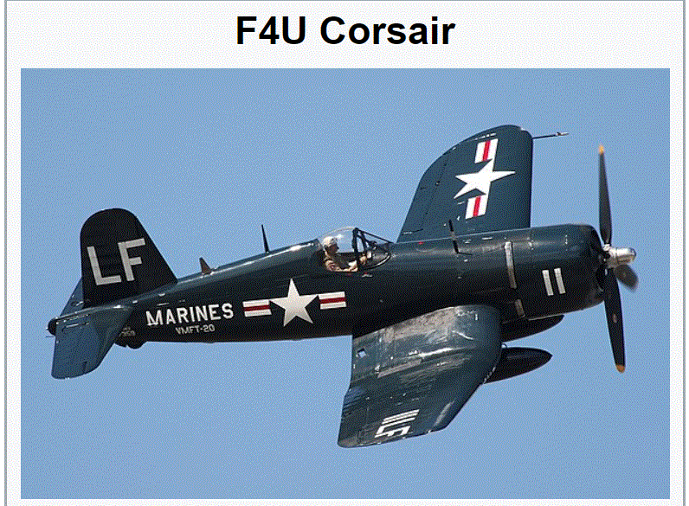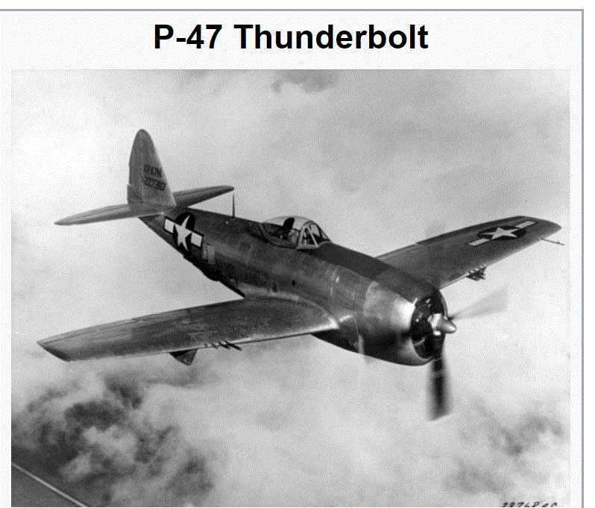
Figure F-1. WWII aircraft with radial engines Source: https://www.wikipedia.org/

Some advantages of a radial engine are that it saves space as it can be attached to the front of the fuselage or the wings. Also, on airplanes such as the ones in Figure F-1, it moves the center of gravity forward. This is a positive thing since it will increase stability. For example, if the plane goes into a stall, it is far more desirable for the center of gravity to be forward of the center of lift. During the stall, the airplane will pitch down if the CG is forward. If the plane were to pitch up, it would only deepen the stall since the angle of attack would only be increasing on the wings which are already stalled. When the nose is pitched down, the lift produced by the wings will increase until the plane’s nose goes back up. The plane may go through a series of stalls and recoveries, but a dynamically stable aircraft with a center of gravity placed more forward will eventually continue with un-stalled flight (Detwiler). One other important point worth mentioning is that during stall, if the CG is in the back, the plane will drop tail first which is very bad! A disadvantage of the radial piston engine is that it is a bluff body, thus increasing pressure drag. This can also be seen in Figure F-1. While many modern aircraft have a more streamlined fuselage, these aircraft with radial engines in the front cause a more turbulent wake behind the engine. As time went on and technology advanced, turbojets began to take the place of radial engines as they became more reliable and were able to generate more horsepower.
Nozzles
From the thrust equation discussed earlier, $Thrust=\dot{m}{(V}_{exit}-V_{inlet})-A(P_{inlet}-P_{exit})$, we can see that the only term in the equation that makes a positive contribution to thrust is $\dot{m}V_{exit}$. One way to increase this term is by increasing $V_{exit}$, the velocity at which the flow exits the system. Now, we need to figure out how to increase this term. From the law of conservation of mass also discussed earlier, you can see that reducing area will increase the exit velocity. This can be achieved by a nozzle. There are many different kinds of nozzles including a subsonic nozzle, supersonic nozzle, variable area nozzle, and single expansion ramp nozzle.
First, a subsonic nozzle can be used to increase the exit velocity when the aircraft is traveling at subsonic speeds. A simplified example of this kind of nozzle can be seen in Figure F-2.
Figure F-2 Subsonic nozzle (source: class PPT)
This figure shows how the nozzle converges to decrease the area from which the air will be exiting. With this kind of nozzle, you can only increase the exit velocity until the flow reaches Mach 1. After this point, the air cannot expand and the relationship between area and exit velocity does not hold in supersonic conditions since density is no longer constant. So the important thing to note here is that the density change starts at Mach 0.3 (compressible flow regime) but the inverse relation between area and velocity holds till the flow reaches Mach 1.
To increase the exit velocity even further, a divergent section can be added onto the convergent section. This converging-diverging nozzle configuration ultimately makes a supersonic nozzle (Figure F-3).
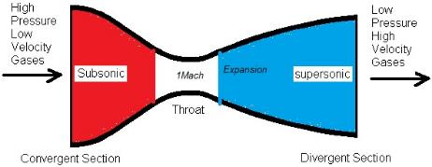
Figure F-3. Supersonic nozzle http://sahil34935.blogspot.com/2013/03/nozzles.html
After the exhaust converges down to the throat, or minimum area, of the nozzle such as the one shown in Figure F-3, the flow “chokes” and reaches Mach 1, then expands in the diverging section and reaches a supersonic Mach number. The velocity of the flow would only decrease in the diverging section if it did not reach Mach 1 in the throat region due to the inverse relationship between area and velocity for subsonic flow. Even less thrust would be produced if this were to happen. When the flow reaches Mach 1, not only is the velocity changing when area changes, density is also impacted. The density of a subsonic flow will remain constant, so only the change in velocity needs to be considered when changing area. The law of conservation of mass indicates that the change in density for supersonic flow is bigger than that of velocity. That means that now when area increases, density will decrease and to conserve mass and momentum, velocity will increase (Glenn Research Center). Very good! This explains why the velocity of the supersonic flow increases as it leaves the divergent section of the nozzle. The nozzle such as the one on the rocket in Figure F-4 use converging-diverging geometry.
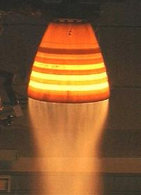
Figure F-4. Supersonic nozzle- converging diverging geometry (source: class PPT)
Since a massive amount of thrust needs to be produced to lift the rocket off the ground, the supersonic nozzle is the best way to produce more thrust.
Some more types of supersonic nozzles include a variable area nozzle (Figure F-5a) controlled by turkey feathers, and the single expansion ramp nozzle (Figure F-5b).
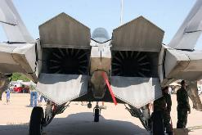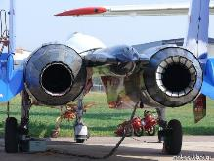
A
B
Figure F-5. Turkey feathers and single expansion ramp nozzles (source: class PPT) Hey Faith, you can also state the name of the airplane where you see turkey feathers and the SERN nozzle! It is always good to know the name of the airplane you are talking about.
On the left side of the figure you can see the turkey feathers on the right engine. This variable area nozzle is meant to change the geometry of the nozzle as the plane is flying at different speeds. At subsonic speeds, you would want the nozzle to be convergent to increase the exit velocity, in other words, a supersonic nozzle. In supersonic speeds, it is more desirable to have a divergent section after the converging section to allow the flow to expand and increase the exit velocity. The single expansion ramp nozzle (SERN) in Figure 5-b is another type of supersonic nozzle which functions to constrain exhaust flow on one side and not the other. This kind of nozzle is still undergoing a lot of experimentation, especially with hypersonic flight.

Noise
One huge problem with airplanes is the amount of noise their engines produce. Whether you are on the plane or on the ground when a plane is landing or taking off, the noise is extremely loud. The chart below shows how loud noise levels are during different stages of flight:
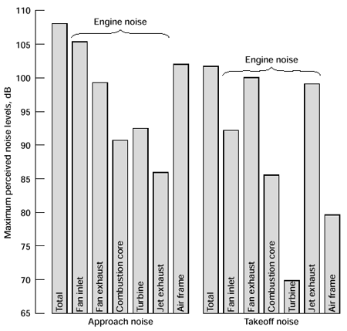
Figure F-6. Noise levels for approach and takeoff (source: class PPT)
From Figure F-6 you can see just how loud the engine noise is. For a frame of reference, the human voice is about 60 dB when speaking in a regular tone standing 3 feet away. When you add up all of the noise an engine makes during approach, this number will exceed 400 dB according to this graph. This noise consists mostly of the mechanical noises from the engine and aerodynamic noise. The aerodynamic noise results from the air flowing around the control surfaces and fuselage and increases along with velocity. There are many ongoing studies to try to decrease engine noise and some new features are being employed to lower noise. One of these is a scalloped exhaust and another is an engine cowling with a chevron shape (Figure F-7).
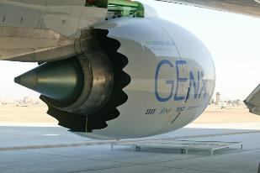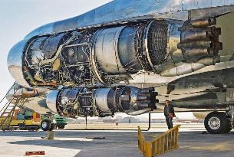
Figure F-7. Scalloped exhaust, pictured left, and chevrons, pictured right (source: class PPT)
The scalloped exhaust has multiple nozzles and is meant to reduce the exhaust noise. The chevron shapes toward the exhaust in the right side of the figure can be seen on a Boeing 787 nacelle. This helps reduce noise by changing how the air that goes through the engine and the air that passes around the engine mix. The hot air coming out of the engine and the cooler air passing around/through the fan will meet at different places because of these chevrons which reduces the air turbulence that creates noise. Noise reduction is of great interest currently as it is a contributor to noise pollution.
In class, Danielle Koch from the Acoustics Branch of NASA Glenn Research Center came and talked to us about noise reduction. She mentioned that their overall goal is to make airplane engines quieter. One study that NASA Glenn is currently working on is a system called a Bio-Inspired Acoustic Absorber. The inspiration for this project comes from the fact that although the average noise level of each individual airplane has decreased over the years, the airline companies have been increasing their fleet size and more planes are being manufactured in general. A graph showing just how many more planes have been manufactured can be seen below in Figure F-8. Awesome!
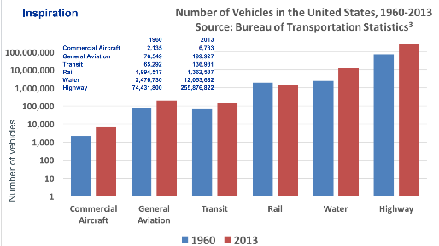
Figure F-8. Increasing vehicles in the United States (source: https://www.grc.nasa.gov/vine/wp-content/uploads/sites/91/Danielle-Koch-BiomimicrySummit2017.small_.pdf)
As you can see from this graph, the production of commercial aircraft, general aviation aircraft, water vehicles, and highway vehicles have increased significantly. The bar may not look much taller for 2013 than 1960, but when you look at the scale of the graph, a small increase means an increase by the thousands or millions. Also, NASA was inspired by nature in this project. They found that natural reeds effectively absorb sound in the 400-1000 Hz range. So, they began thinking about how reeds could function to reduce noise in aviation applications. Since natural reeds cannot withstand a lot of the force in industrial settings, they manufactured synthetic reeds that resemble these natural reeds that still absorb a great deal of low frequency noise. During testing, there were different kinds of prototypes (Figure F-9). 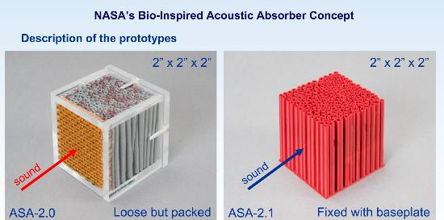
Figure F-9. Synthetic reed prototypes (source: https://www.grc.nasa.gov/vine/wp-content/uploads/sites/91/Danielle-Koch-BiomimicrySummit2017.small_.pdf)
One was an acrylic box that had loose reeds backed together, pictured on the left of Figure F-9. This model was a 3D model as the cross section varied across the length of the shape. The right of Figure F-9 pictures the prototype where the reeds were held in place simply with a base instead of being packed inside a retainer. This prototype was 2D instead of 3D since the cross sections of the shape are the same in the lengthwise direction. In the loose and packed prototype, the sound entered the model through a Nomex honeycomb device. For the fixed model, sound was introduced without the honeycomb. The results of testing can be seen below in Figure F-10.
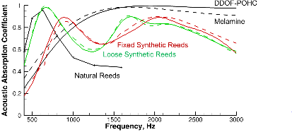
Figure F-10. Loose v fixed synthetic reed prototypes (source: https://www.grc.nasa.gov/vine/wp-content/uploads/sites/91/Danielle-Koch-BiomimicrySummit2017.small_.pdf)
This graph shows how effective the synthetic reeds were, especially at a frequency of less than 1000 Hz which is what the team was focusing on. Danielle Koch mentioned that the team working on this project is currently looking at how this type of absorption system can be implemented into aviation and industrial settings to control low frequency noise (Koch).

How to Reduce $\dot{m}V_{inlet}$
Next, we looked at another way to optimize thrust: decreasing the value of $\dot{m}V_{inlet}$. From the thrust equation, $Thrust=\dot{m}V_{exit}-\dot{m}V_{inlet}-A(P_{inlet}-P_{exit})$, it is clear that minimizing this value will prevent thrust from being reduced. Since momentum is mass times velocity, this value is simply the momentum of air coming into the engine. One possible way to decrease this momentum is by boundary layer ingestion. The D8 Double Bubble design discussed in the coefficient of pressure section implements boundary layer ingestion (Figure F-11).
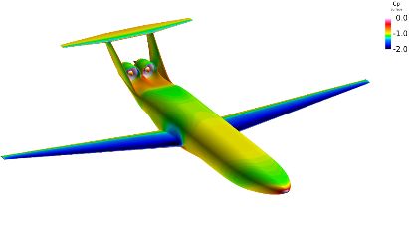
Figure F-11. Boundary layer ingestion in the D8 design (source: class PPT)
The placement of the engines behind the fuselage of the plane allows boundary layer ingestion to occur. The idea behind boundary layer ingestion is to introduce slower moving boundary layer flow into the engine so that the same amount of thrust can be achieved by adding less energy. When the air is already moving quickly, even more energy needs to be added to flow to produce a lot of thrust. To revisit what was discussed in the coefficient of pressure section, a lower coefficient of pressure indicates the LOCAL (not lower) velocity of the air at points close to the surface when compared to the freestream velocity. Since the velocity is lower, this decreases the value of $\dot{m}V_{inlet}$. Another application of boundary layer ingestion is being studied in NASA’s Single-aisle Turboelectric Aircraft with an Aft Boundary Layer propulsion system (STARC-ABL). On a wing-mounted engine, a turbofan engine pulls air into the engine and accelerates it to produce thrust. In doing so, drag is produced as the air resists the plane and engines flying through the air. The innovative part of this design is a boundary layer ingesting fan on the tail of the plane (Figure F-12).
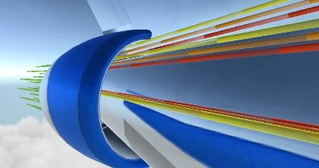
Figure F-12. STARC-ABL concept (source: class PPT)
This would reduce overall drag on the plane by allowing the engines mounted on the wing to be smaller. Also, it produces thrust by ingesting the slow-moving boundary layer air and accelerating it. To power the fan, generators would be added to the engines on the wings to produce electricity to power the motor and fan. This turboelectric concept is being tested by NASA researchers for possible future development.
Another way to decrease the momentum of air coming into the engine is to increase the area of the engine inlet area. As previously discussed, the velocity of the incoming air will be lower when area increases for subsonic flow. Also, compressors near the engine inlet compress the air, which increases pressure (Figure F-13).
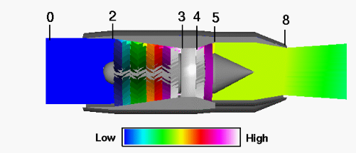
Figure F-13. Pressure differences in a turbojet engine (source: https://www.grc.nasa.gov/www/k-12/airplane/epr.html)
This figure shows how, as the air moves through the compressor, the air pressure moves from very low to very high. The compressor functions as several rows of airfoils. As the flow moves through, each row produces a slight increase in pressure. The compressor also slows down the velocity of the air before it enters the combustion area, effectively reducing the value of $\dot{m}V_{inlet}$.
Boundary layer splitters also reduce inlet momentum. The purpose of this is to divert boundary layer flow from passing through the engine. A photo of a boundary layer splitter can be seen below in Figure F-14. So Faith, you have to set some context on why we talked about BL splitter. While some engines can ingest BL, especially the ones which are in experimental stage, most of the engines available now they don’t like the turbulent flow created by the BL entering the engine. That is why they have the BL splitters to cut off the BL from entering the engine.
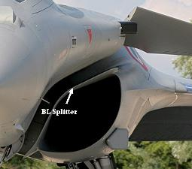
Figure F-14. Boundary layer splitter (source: class PPT)
As the airflow flows past a body like the fuselage of an aircraft, the boundary layer grows in thickness. This means that the air grows more turbulent and has a lower pressure, which is the opposite of what is favorable in engine intake. This boundary layer splitter helps channel airflow into the inlet by cutting off the BL. Many aircraft SUCH AS? use variable geometry inlets to achieve this same effect without needing the boundary layer splitter.
Another way to reduce intake momentum is by taking advantage of shock waves (IN SUPERSONIC AIRCRAFT). Shockwaves can help slow the airflow and there are several different kinds of supersonic inlets that function a bit different. First, there are 1D inlets (Figure F-15).
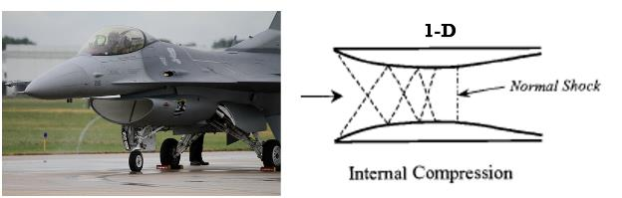
Figure 15. 1D supersonic inlet
As demonstrated in the diagram on the right of Figure F-15, the shockwaves reflect from the surface and create another shockwave until they meet and create a normal shock perpendicular to the airflow. These shockwaves also allow for pressure recovery and will reduce the airspeed to a value below Mach 1, which is necessary for the flow to pass through the engine. The reason they are called one dimensional inlets is because the shock wave is simply a vertical shock. Second, there are 2D supersonic inlets (Figure F-16).
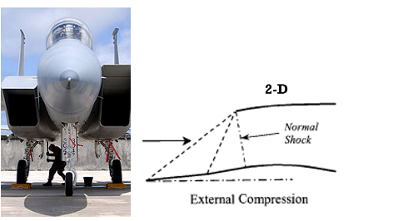
Figure F-16. 2D supersonic inlet
A 2D supersonic inlet gradually decreases velocity through variable geometry and oblique shockwaves. There may be one or multiple oblique shocks and a normal shock. This is illustrated above in the ride side of Figure F-16. Through this, the flow reduces to a subsonic speed. This kind of inlet also functions as a compressor, so it compresses the air and increases the pressure of the intake flow. Lastly, there are 3D supersonic inlets. This type of inlet can be seen in the same of a cone on many planes that fly at extremely high supersonic speeds such as the SR 71 Blackbird (Figure F-17).
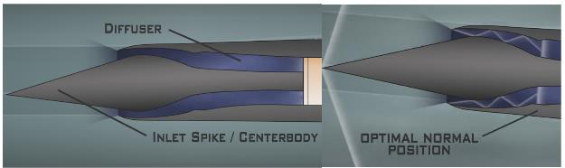
Figure F-17. 3D supersonic inlet in an SR 71 engine
As shown in this figure, the 3D conical inlet consists of an inlet spike/centerbody as well as a low pressure turbulent air diffuser, which is where the compressed air spreads out before entering the engine. The apex of the cone takes the pressure of the leading supersonic wave so that the engine gets the best possible airflow. As the air passes through the inlet, a series of oblique shocks occur and then a normal shock occurs. At this point, the flow changes from low pressure supersonic flow to high pressure subsonic flow, which is what will optimize the amount of thrust an engine produces. The position of the normal shock in the right side of Figure shows the optimal position, which occurs at Mach 1.6 in an SR 71 Blackbird. To keep the normal shock in this optimal position, the inlet spike retracts 1.6 inches for each 0.1 increase in Mach number above Mach 1.6. . (A total of 26” when flying at Mach 3.2) This changes the relative geometry of the inlet and accounts for the increasing airspeed. At this optimal position, pressure recovery, or the percentage of pressure that results from the supersonic flight that gets translated into usable pressure inside the diffuser, is at its highest, about 90%. When the inlet spike retracts at these 0.1 Mach number intervals, it helps keep the pressure recovery as close to this value as possible. In general, the purpose of these inlets is to reduce the flow from supersonic to subsonic speeds before it passes through the engine with high pressure recovery The type of inlet that the airplane uses is dependent on how fast the plane is meant to travel and for what purpose.

Pressure and Thrust
The difference between inlet pressure and exit pressure also impacts how much thrust is produced. This is supported by the last term in the thrust equation, $Thrust=\dot{m}V_{exit}-\dot{m}V_{inlet}-A(P_{inlet}-P_{exit})$. Since a positive value of this term reduces thrust and area is always positive, it would be ideal to have an exit pressure that is higher than inlet pressure. However, this typically doesn’t happen since the exit velocity tends to be higher, which means pressure will be lower. If this were to occur though, the term would be negative and actually contribute to thrust. If the inlet pressure and exit pressure are the same, then the term goes to zero and has no direct impact on thrust.
In class, we were given a worksheet that we filled out that showed how pressure differences affected thrust and performance in both a subsonic and supersonic condition. Were you able to understand those concepts? In the subsonic case, we saw that as the difference between inlet pressure and exit pressure grew, the Mach number increased since lower pressure at the exit indicates a higher velocity. Also, in the subsonic condition, Mach number cannot be increased past 1 as this is the limit for a converging nozzle. To increase the speed past Mach 1 a diverging section is needed. The supersonic case did have a diverging section where the Mach number increased again as the difference between inlet/ambient pressure and exit pressure grew. At a certain point, a shockwave occurs which increases Mach number even more since more thrust is produced. For each case, there is an ideal condition that optimizes pressure difference and Mach number at a certain altitude. In the supersonic scenario, we learned about when shock diamonds and expansion waves occur (Figures F-18 and F-19).
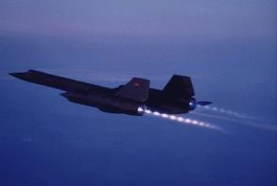
Figure F-18. Shock diamonds on an SR-71 Blackbird (source: class PPT)
The shock diamonds on the SR-71 Blackbird as pictured above occur when exit pressure is trying to “catch up” to ambient pressure, otherwise known as backpressure. This will typically occur at lower altitudes as this is when ambient pressure is at its highest. Each individual “diamond” is when a shock wave is paired with an expansion wave. So to be clear, since the exit pressure is lower than the ambient pressure, the only way the flow can go from low to high pressure in a fast way is through series of shock waves. That is exactly what is happening behind the nozzle.

Figure F-19. Exhaust plume from expansion waves (source: class PPT)
The figure above shows what happens when the exit pressure is greater than ambient pressure. A large exhaust plume comes from the engine as the flow expands from the region of high pressure to lower pressure.

Types of Jet Engines
There are many different kinds of jet engines I will talk about in this section including the axial engine, turbojet, turbofan, turboprop, ramjet, and supersonic scramjet. All of these different kinds of engines started with Frank Whittle’s invention of the first jet engine (Figure F-20).
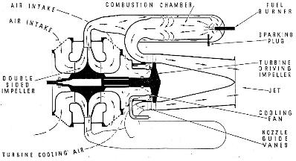
Figure F-20. Schematic of Frank Whittle’s first jet engine (source: class PPT)
This schematic shows the general airflow throughout Whittle’s engine design. As you can see, there are a lot of turns that requires the flow to change directions very quickly and results in a loss in total pressure and therefore efficiency of the engine. This design was developed into the Rolls-Royce RB.23 Welland engine that powered the first British jet aircraft during World War II. This engine compressed air using a centrifugal compressor by spinning the air and allowing the centrifugal forces to compress it. The centrifugal force forces the air out to the side where it will burn in the combustor. Then, it exits through the turbine which powers the compressor. The same issue was present in this engine as Whittle’s original engine—the air had to go around the corners, limiting the power of the engine. The Rolls-Royce Avon engine overcame this issue with an axial compressor, or a series of turbines which pushed the air into the engine by propellers. Another early engine was the Von Ohain axial flow turbojet engine (Figure F-21).
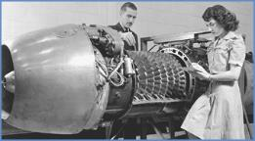
Figure F-21. Von Ohain axial engine
This engine also got rid of the issue of lowering pressure from excessive turns in Whittle’s engine. As you can see, there is an axial compressor just like the Rolls-Royce Avon engine.
Next, a turbojet engine is the simplest kind of gas turbine/jet engine (Figure F-22). 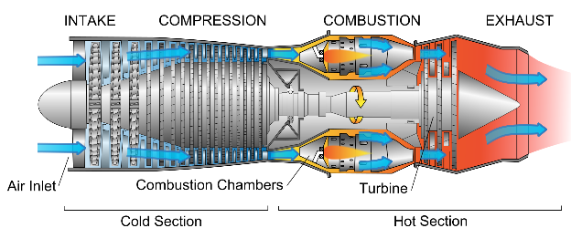
Figure F-22. Turbojet engine (source: class PPT)
After air enters through the inlet (intake), it enters the compressor, which acts as continuing rows of airfoils, producing small jumps in pressure as mentioned earlier. By the time the air makes it through the compressor, these small jumps add up to a large difference when compared to freestream pressure. In the combustion stage, fuel and air combine and ignite. Then, the exhaust moves through the turbine which extracts energy from the flow by making the blades spin in the flow (Glenn Research Center). This is important—the energy the turbine extracts powers the compressor as they are connected by a central shaft. The energy that is left over after passing through the turbine leads to thrust when the velocity increases through the nozzle. In the end, the flow’s exit velocity will be greater than that of the freestream. A turbojet engine usually has a fairly small cross-sectional area and relies on exit velocity to increase thrust because the mass flow rate does not increase by much as the flow moves through the engine.
Another kind of engine is a turbofan engine (Figure F-23).
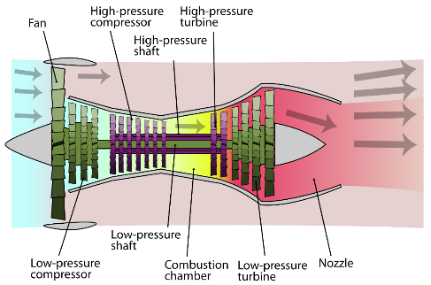
Figure F-23. Turbofan engine (source: class PPT)
Most modern airliners use this kind of engine. They are known for their great fuel efficiency and high production of thrust. It is a more modern type of jet engine than the turbojet engine. A turbofan engine consists of a core engine, fan, and additional turbine. When the flow goes through the inlet, some air passes through the fan and continues through the compressor and combustion chamber just like the process for a turbojet engine. The rest of the air bypasses the core engine. The air coming through the fan has a higher velocity than the freestream, so it does contribute some amount to thrust. In other words, the total amount of thrust produced from a turbofan comes from both the air passing through the core engine and the air that goes through the fan but bypasses the engine. Here, it is important to mention bypass ratio, which is the ratio of air that bypasses the core engine to the air that passes through the core engine. It was mentioned in class that up to 90% of thrust can come from the bypass flow. That is a significant amount and shows how much more thrust is produced in a turbofan engine when compared to a turbojet engine. If you can, please look up the general magnitude of thrust from each type of engines.
The next kind of engine we discussed was the turboprop (Figure F-24).
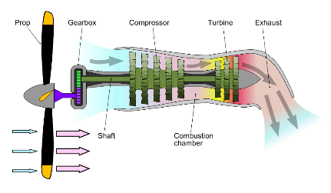
Figure F-24. Turboprop engine (source: class PPT)
Turboprop engines can be found on many smaller low speed transport aircraft. Also, some cargo aircraft have turboprop engines, sometimes multiple along the span of the wing. Instead of fan, are propeller brakes at the inlet of the engine. These propeller blades increase mass flow rate. Much of the energy of the exhaust goes into powering the turbine, gearbox, and propeller. Because of this, the exit velocity of the flow coming out of a turbofan engine is fairly low and does not contribute as much to thrust. The thrust mostly comes from the propeller and increased mass flow rate. When the plane is flying at higher speeds, the turboprop engine will be less efficient since propellers become less efficient at higher speeds (Glenn Research Center). This is why they are typically found on low-speed transport planes.
The last two engines we discussed were the ramjet (Figure F-25), and supersonic ramjet, otherwise known as the scramjet (Figure F-26).
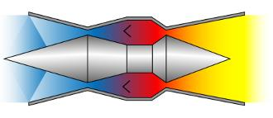
Figure F-25. Ramjet (source: class PPT)
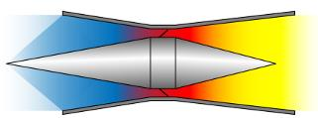
Figure F-26. Supersonic ramjet/scramjet (source: class PPT)
The ramjet in Figure F-25 is much different than the other engines we have discussed such as the turbojet, turbofan, and turboprop. The ramjet compresses the air without using an axial compressor (just by using shock waves), which the all of these other three engines used to compress the flow. Instead, shockwaves compress the air with the inlet spike and slows it to a subsonic speed where combustion occurs. As you can see from both diagrams, there are not many mechanical elements as there were in the other engines. This makes these types of engines much lighter and simpler mechanically. A negative aspect of the ramjet is that they cannot produce thrust when the plane is not moving as it depends on the airflow coming in to produce the thrust. Therefore, the plane must be accelerated using some other propulsion system to the point where it starts producing thrust. Ramjet propulsion is less efficient (around Mach 5 according to NASA). The scramjet (Figure F-26) solves this by making it so combustion occurs in supersonic conditions. They are meant to operate in high supersonic/hypersonic speeds. I read through Brian Dunbar from NASA’s article, “What is a Scramjet?”, and he mentioned that researchers predict airplanes with scramjets could fly at Mach 15 (Dunbar). Awesome! NASA has a Hyper-X program that is currently working on implementing scramjet technology into aviation today. It will be interesting to see whether this technology is used in the future to fly at these extremely high speeds.

Reflection: The most important thing I learned in this topic was the thrust equation and how it was derived. This equation guided us through our entire discussion of thrust and explained how different parameters contributed to or reduced thrust. As the worksheet we were given in class said, it makes sense to begin the topic with equations. This allows us to know what affects thrust from the beginning. I think the discussion of the different kinds of engines was of high importance as well. Different planes use different engines and it is important to understand how each one functions and why one type would be better suited for a specific airplane over another.
I do not have any specific questions over this topic, but I was a bit confused during the discussion of pressure and thrust. The worksheet with the pressure ratios confused me and I think I understood the main takeaways but I did not really understand what was going on in between the beginning and the end. That is alright but all we were trying to do is to prove that there can only be one efficient condition for a given nozzle in supersonic speeds.
I can use this information in the future since now I have a basic understanding of how different kinds of engines work and how airplanes produce thrust. This will be useful, just like everything else we have learned this semester, in future aerospace classes and learning how to design a plane. The only suggestion I have for presenting this topic better would be making the discussion about pressure and thrust a bit clearer. Other than that, the order we went through made sense as it built off what we learned the previous class.

