Lab: Project Decision and Planning

The purpose of this lab is to refine and/or combine the prototypes you built from last lab, use decision matrix to choose one solution. After you deciding upon the prototype to build, you will generate a bill of materials for the prototype, and create a project schedule.

Task 1: Choose a list of criteria and their weight.
Come up with a list of criteria that you will use to compare different solutions. Assign weight using interaction matrix if you think they are not equally important.

Task 2: Select one design solution.
Improve and/or combine the three prototypes you built last lab based on the feedback you received. Use decision matrix to choose one solution to implement. Provide a detailed description of your chosen design.

Task 3: Create a bill of material (BOM).
Create a table of the parts and building materials you will need to build your prototype. Include price and quantity for each item. Come up with a total budget.

Task 4: Build a project schedule using Gantt chart.
Create a project schedule (Gantt Chart) which includes all major deliverables and tasks necessary to build a working prototype of your solution to complete the project. The more specific your tasks are, the more useful this schedule will be.

As a team, create a Gantt Chart for your project (Refer to Appendix for details on how to make and use a Gantt chart). On your Gantt chart, it is important to include all of the tasks that your team has identified as necessary to complete the design project. Also, make sure that all deadlines are met (i.e. all deliverable due dates, etc.). You should also consider holidays when making your schedule. You can create the Gantt chart using Excel, or you can also create it by hand, but it must be done neatly.

Task 5: Build a prototype/mockup/CAD model
Modify the prototype from last week or rebuild a new one. It will be used during next week’s presentation to help illustrate your design concept. A preliminary CAD model is also acceptable. Take a picture of your prototype or a screenshot of your CAD model.

Appendix: How to make and use a Gantt Chart
Making a Gantt Chart
In a Gantt chart, tasks are listed in the left column (one task per row), and dates run along the top in increments of days, weeks, or months depending on the total length of the project. The expected duration of each task is represented by a horizontal colored bar, with the left end at the expected start date for that task, and the right end at the expected completion date. Some tasks may run simultaneously (in parallel), some may overlap in time, and some may occur sequentially (one task ends, then another starts). If a task is dependent on another task, the two tasks are connected with an arrow to indicate that one cannot start until the other ends. For example, if Task A is to purchase materials, and Task C is to build a prototype, Task C is dependent on Task A because you cannot build a prototype until after you have purchased the necessary materials. A Gantt chart example is shown in Figure 1.

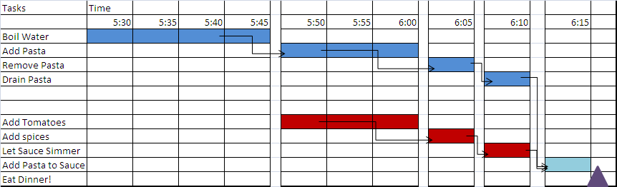
Figure 1. A Gantt chart example

It is often a good idea to include milestones or other events on your Gantt chart that indicate your progress. For example, you may want to include when the final prototype will be complete, when certain project deliverables are due, etc. These ‘milestone’ events are entered as a symbol (often a triangle or diamond) on a single date on the Gantt chart as shown in Figure 1.

Using and Updating Your Gantt Chart
You should check your Gantt chart at the start of each lab to identify what tasks need to be completed that day, and to ensure that your team stays on track to successfully complete the project on time. As you proceed through the design process, you may identify more specific tasks that should be added to your project schedule. The project schedule should be continually updated, i.e., when you identify additional tasks that need to be completed, you should add them to the Gantt chart. The more detailed you can be early on in making your schedule, the easier it will be to complete the project on time (for instance, “build prototype” is not as useful of a task as “ Build part A,” “Build part B,” “Connect A to B and secure to base,” etc.).

