Dear Team 3,

So sorry to sound informal with that team name – that’s Professor Webb’s doing, not mine! I wanted to tell you first hand how delighted I was with your recent proposal for the tree trunk to support my “epic tree house”. It has been a joy to me to know that my favorite offspring of my dear brother is engaged in engineering pursuits and that you were excited to help out with the trunk design. I am also happy to hear that you assembled a team of other engineering students to help you in this activity; more brains are better, I’ve often found.

Anyway, I am hoping herein to describe my final design decisions, many of which are based on the suggestions made by your team. For some details, I used inspiration from your proposal but made changes to better suit my desires. I’m hoping that, with what is described below, you will know very specifically the total length of the trunk I desire as well as the material to use throughout the design. I believe that Professor Webb would call these things L_{tot} and E(x). I also describe the levels of the tree house I want to mount to the trunk and where I would like them to go; thus, I am hoping you can turn that into specific information about the external loads on the trunk due to the house. Professor Webb would point out that these are contributions to the overall P(x). Given that information, I am asking your team to optimize the cross-section of the trunk in a manner that I describe further below. So I am asking you to optimize A(x). To repeat, I provide below some specifics about the cross-section I desire and I even put on my engineer’s hat to suggest a way for you to constrain your optimization exercise (i.e. to make it more tractable). Please read what I provide below and formulate questions your team has – Professor Webb intends to discuss this activity extensively with you so your questions will be answered as fully as possible.

First, after perusing your suggested trunk heights, I would like the total height to be 120 ft –a bit higher than you suggested. I really like Ryan’s suggestion of steel so we will use that material throughout. We’ll use a 300 series, corrosion-resistant steel; as Professor Webb would point out, for your purposes, that means E(x) = 29 x 10⁶ psi for all values of x. He is a stuffy one, isn’t he?! Anyway, we are very lucky to be working with a master artist/designer who will create for us a faux bark to be mounted on the steel trunk. He’s designing branches, faux leaves – his work is stunning and this is going to look great. However, you don’t need to worry about that part, except to know that this thing will not look completely out of place among the pines and firs up here! The weight added by those aesthetic details will be relatively small so we will ignore it, except for the fact that we will use a factor of safety of 2.5 on the yield stress and critical buckling load. More on that below.

Now, about those suggested house designs: great work! Really: just wonderful! I hate to choose favorites among your designs but I really resonated with the multiple levels proposed by Doyle. I must confess that I now desire a larger total square footage than I originally imagined (and much larger than what any of you proposed!). An old friend of mine pointed out that, to host the sort of parties I am known for, I will want more space. Your proposals inspired me to spread that space out among multiple levels! Absolutely charming suggestions, really. So here’s what I’m thinking: please plan for a large, two-story structure somewhat lower down, with ~5500 ft², as well as a large single story level whose top coincides with the top of the trunk; that last level should be ~2000 ft². I would like 10-foot tall ceilings so you should plan for each story to be of sufficient height to accommodate this. The two-story level should be two times whatever height you determine for each story, of course! When you calculate the total force applied on the trunk by each level, you should then divide that among 3 mount points for the single story level and among 5 mount points for the two-story level. Our consulting structural engineer has said you should evenly distribute the mount points along the length of the trunk occupied by the given level. By the way, your team was really outstanding in addressing loading on the trunk by the houses in your proposed designs – nice analysis (I just want a bigger house now)!

In addition to the external loads on the trunk due to the house levels, you will see below that I desire an elevator to be installed inside the trunk. A different friend of mine pointed out that my friends aren’t getting any younger and I may want to provide an easy way to get to the highest level. It will be a relatively small elevator so the total load due to it that you should account for in your design is 10 kips; also, that will be applied 2 ft below the top of the trunk.

OK … now here is where I really need your help (and also where I deviated from your suggestions a bit). Because of the elevator, I want a hollow trunk and the minimum interior radius should be 3 ft. I agreed with Doyle’s proposal that tapering is more aesthetically pleasing; however, I think I’ve gone a bit further with my desires. Also, it won’t be a façade. I want the trunk to flare in a way like what I show in the sketch below. Please pardon my lack of drawing ability; then again, you are used to Professor Webb’s lack thereof so you should not be too shocked over mine! Don’t tell him I said that! But, basically, I want the minimum radius for both the inner and outer wall of the trunk to occur at the same position in x and that should be ~65%-75% of the way up the trunk. Also, above that point, it should flare out less (i.e. up to the top) than it does below that point (i.e. down to the ground). My drawing, though, is not really done to scale very well so I think I’ve exaggerated that flaring – it probably can be less and still look good and be structurally sound. Also, I don’t know what the minimum wall thickness should be. I also don’t know how that thickness should vary (perhaps not at all – I doubt that, though).

Professor Webb pointed out to me that you can get this sort of shape if you describe both the inner and outer radius of the cross-section with parabolic equations; for example:
R_{in}(x) = ax² + bx + c
R_{out}(x) = dx² + ex + f

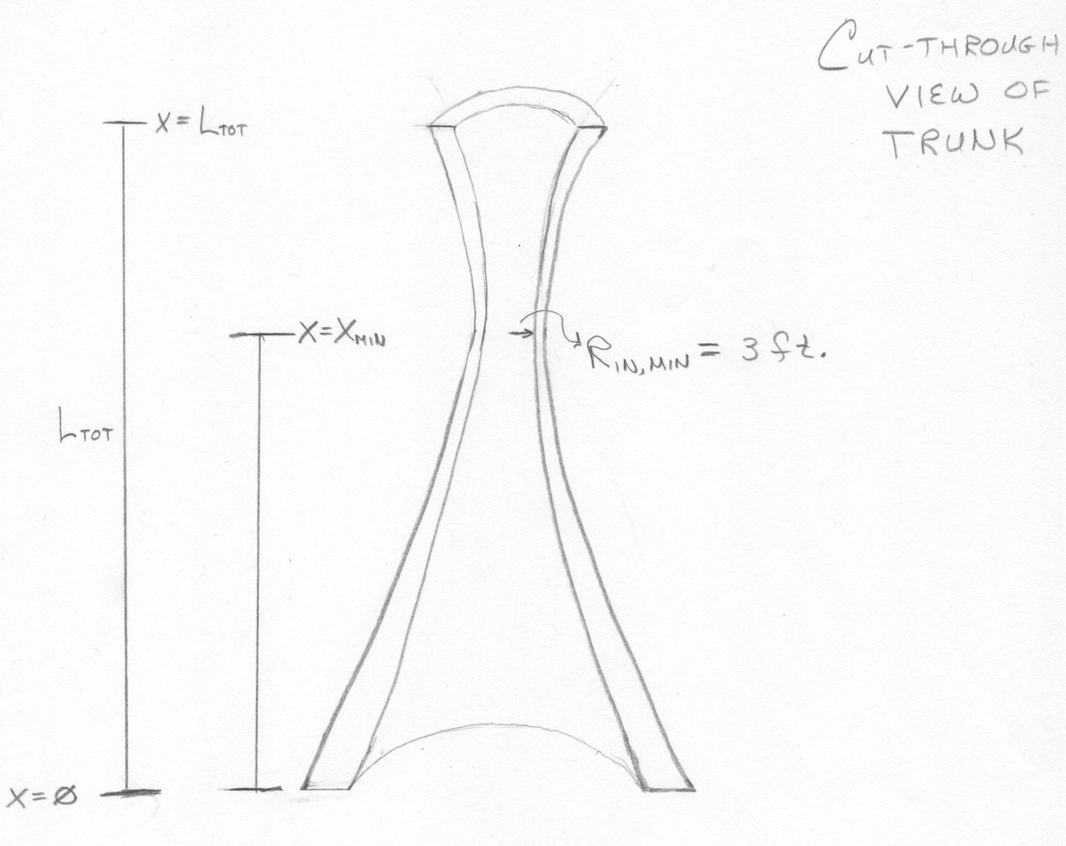
If you know the value of, say, R_{in} that you want at three different values of x, then you can fairly easily solve for a, b, and c in the first equation. The same thing is true for R_{out} and d, e, and f in the second equation. So, if you fix that the minimum value of R_{in} is 3 ft and you set the x-coordinate where that occurs (say, 70% of the way up the trunk), then you have one of the needed pairs of x and R_{in} for determining a, b, and c. Then, if you select reasonable values of R_{in} at the top and bottom, you have the two remaining pairs of x and R_{in} that you need to solve for a, b, and c. Do a similar thing for three pairs of x and R_{out} values and you can solve for d, e, and f.

So I would like for you to optimize the cross-section shape and how that varies as a function of x, given the external loads from the house, the elevator, and the weight of the trunk itself. For this grade of steel, the manufacturer has a quoted yield strength of σ_{Y} = 42 ksi, but don’t forget the factor of safety discussed above. Professor Webb has assured me that he will address in lecture how you should estimate a critical buckling load. I would like a trunk design that satisfies the constraints due to both yield and buckling. For yield, this means that nowhere along the length of the trunk should the stress exceed 16.8 ksi (σ(x) < 16.8 ksi for all x, as that math lovin’ Professor of yours would say!). To be optimized, the stress should also not be grossly below this value throughout the length. Again, Professor Webb will instruct you in how to perform your buckling analysis but one thing you will need to carry out that analysis is a highly accurate description of P(x).

As far as how I would like you to document your design and related stress analysis, Professor Webb will convey that to you in a separate document. For now, you know that you need to create an analysis tool that will allow you to compute – with high accuracy – both the stress and the internal load as a function of x. So you’ll need to create a 1D finite element analysis code that addresses a hollow circular cross-section “rod” with varying inner and outer radius. It has to account for loading due to the tree house levels, the elevator, and the weight of the trunk itself.

If you have questions, Professor Webb has also assured me that he will answer questions on my behalf and he will do so as completely as he can. He will make suggestions, help you decipher his posted flow chart for a 1D FEA code, help you with errors along the way, and spend some time in lecture discussing this exercise. So I do hope you will enjoy this exercise and help me create a trunk I feel safe in and I also feel aesthetically pleased with.

Thank you in advance and best of luck!

Fondest regards,
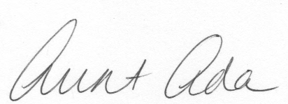

Aunt Ada

