1. How many students are there in the class?
Currently, there are 28 students in the class. The class is intended to target Sophomore level students but this year we had a very interesting mix of students all the way from first-year students to sophomore. The statistics of the students are shown below in Figure 1. The current semester is also the first semester where we had students from other departments as well. We had one student from chemical engineering and one student from engineering technology.
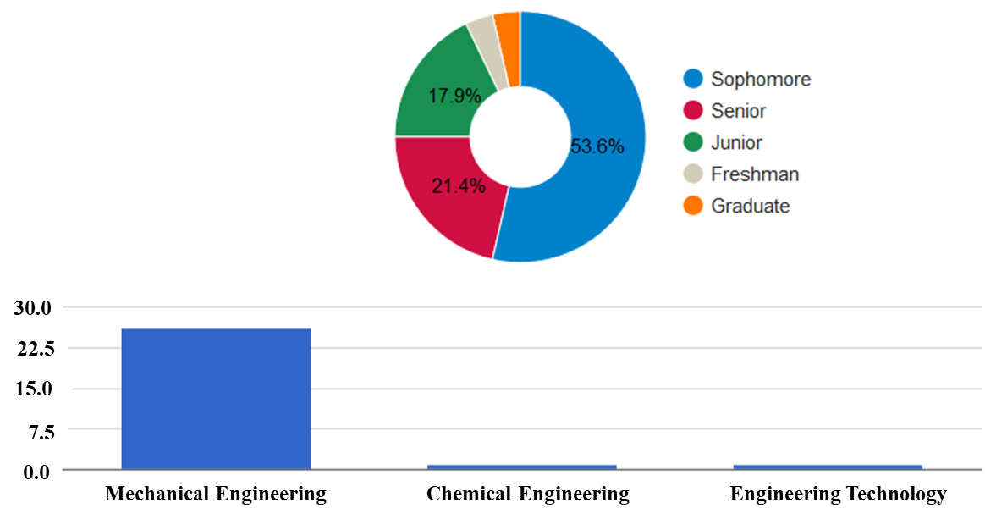
Figure 1 MEE 225 – Introduction to Flight Class Statistics
2. Who should implement this project? Who would this project work well for?
The project will be suited for an introductory class involving flight, jet engines or propulsion. The project covers the most fundamental concept of thrust and the design of the jet engine. It can also be used to teach students how equations help design a system. This project exposes students to the mathematical formulation of equation of thrust. Therefore, it can be used in a fluid dynamics class as well to expose the students to the most powerful and applicable equation in continuum mechanics: Newton’s second law. I also used similar module in a graduate compressible flow class to teach students about the role of supersonic inlets and nozzles.
3. How much time was spent on this project/course?
At UD, the Introduction to Flight Course is offered every spring and fall semesters. There are two one hour and fifteen-minute classes every week. In total there are about 28-30 classes in each semester.
Even though this is an introductory course, the amount of time spent to create the modules and the concept inventory is about as same as any other course. As an instructor, the class preparation time depends on the interest of the students. If most of the students are interested in a particular topic, I am going to spend time to prepare that topic and cover it in class. I make it a point to not cover everything in the concept inventory and choose what the students are interested to know. So I cannot put a number on the time that was spent in the course. Every time I teach this course, the concept inventory covered in class varied slightly. For example, most of my students were interested in the SR-71 airplane. So I had to spend time to incorporate the SR-71 in the topics such as the aircraft performance (takeoff, landing, turn, etc.), engines, wave drag, etc. Over the three years I taught this class, I used examples of multiple airplanes depending on students’ interest.
For the specific module of “Why Jets Fly So High,” I spent about 5 hours for the preparation of guided notes, presentations and feedback. I could not implement the “electric fan” component of the module in the Fall 2017 semester because of lack of time, but all the other learning objectives were met. The assessment of student’s performance in this module is done through “Portfolio” which takes several hours for the instructor given the amount of students in the class. But the method of assessment can be changed depending on the instructor.
4. Instructor Reflections:
I was a little hesitant to introduce the topic of thrust with the thrust equation, but upon several iterations, the equation of thrust seemed to be a common platform which connected everything. The concepts that converges into the thrust equation are:
1. Conservation of mass
2. Conservation of momentum
3. Subsonic diffuser and nozzle
4. Supersonic diffuser and nozzle
5. Turkey Feathers
6. 1D, 2D, and 3D supersonic inlets
7. Placement of engines (Ex: D8-Double Bubble, STARC-ABL)
8. Boundary-Layer Splitters
9. Whittle's engine
10. Role of compressors and turbines
11. Different types of jet engines
12. Relationship between area, Mach number, and Pressure (Relationship between Exit pressure and Backpressure)
Using the equation of thrust, there is an excellent opportunity for the students to connect the dots and see how all the topics mentioned above are related. The intention is also to let the students realize how one topic applies to another and how different concepts contribute to one application. The books don't do that.
The list of topics mentioned above is what I had in the beginning of the class. And I had to find a way to integrate all of that and tell a ONE COMMON story. And that's when I came up with this thrust module. And all of that can be tied back to the one simple equation of thrust. And that is the reason why I started with the thrust equation. The concept of disruption or colliding ideas applies to everything, even teaching. And I love how well connected they are. And most of the topics covered in class are connected with each other. Changing one changes everything else. I wanted the module of thrust to be a good learning tool, but I wanted the students to get an experience of how equations are married to the design aspects of an engine. I was amazed that students understood the relation between the exit pressure and back pressure which is a topic usually covered in graduate class. With all knowledge and experience students gained from this module, I hope they don't look at an engine the same way they did before.
I was also surprised that I was able to cover more material a lot more clearly through this module than I would have otherwise. As an instructor, the module helped me immensely to navigate through these topics and also to let students find the connection between design and mathematics.
If I would have done anything different, I would have managed the timing a little better with assessments in-between the module instead of just one assessment in the end of the module. Multiple assessments in between the module help to keep track of the student learning in each stages of the module. We spent around 2.5 weeks (five 1.15 hour classes) going through this module so two assessments in between would have been sufficing. Since this is also the first time I implemented this module, we didn’t have enough time to do the ducted fan experiment which is the “apply and create” objectives of the module.
4.1 Changes I made in class:
I incorporated a lot of similar modules in the introduction to flight class this semester. Below is the list of things we did along with some of the logistics:
- 28 Classes
- 25 Instructor Reflections
- 5 Portfolio Drafts totaling (~100 pages for each student)
- 4 Projects
  - Wind Tunnel Experiments for Determining Coefficients
  - Assessing Aircraft Performance analysis using equations and Flight Simulator
  - Air Force Museum Scavenger Hunt
  - Glider Experiment for Stability Analysis
- 3 Homework Assignments
- 1 Passion Project
- 1 Innovation Challenge and Poster Presentation to Tom Morgenfeld (F-35 Test Pilot)
  - Challenge: HOW CAN FLIGHT BE INCORPORATED ON A DAY-TO-DAY BASIS BY A COMMON MAN?
- 2 Guest Speakers
- 1 Delicious Dinner
- 1 Night of Pizza, movie and fun
- KEEN Modules:
  - Aviation Pioneers
  - Parts of Airplane
  - Helium Balloon
  - F-15 activity
  - Gimli Glider Activity
  - R/C Gliders
  - Why Jets Fly So High?
And the big change of all is that I moved the class to a more collaborative and engaging space (an art studio) as shown in Figure 2.
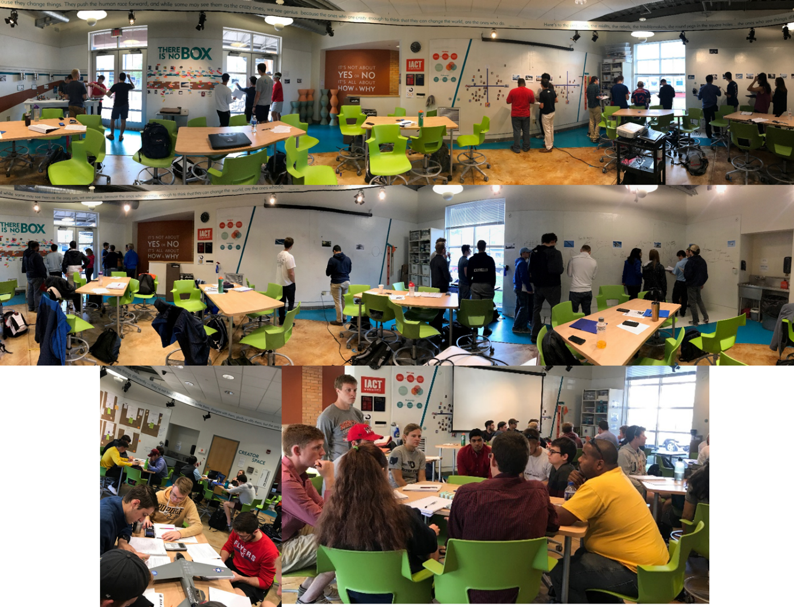
Figure 2 Classroom where Introduction to Flight was held in Fall 2017. The space is an art studio.
Classroom atmosphere is an important factor in learning and engagement of the students. Dull, dark and monotonous color of the conventional classroom walls is not exciting nor inviting. The classroom where introduction to flight was taught shown in pictures above, there are movable chairs and tables which the students can arrange any way they want to engage within the group or with other group.
4.2 Changes you suggest for class/project:
Even though with all the modules the class is still concept heavy. More hands-on activities might help the students with making connections between day-to-day flight.
A lot of changes can be made to the module in discussion such as
- Assessment: As I mentioned earlier, multiple assessment can be implemented at various stages in the module. Also, feedback on the module can be collected at various stages as well rather that at the end of the module.
- Use of props: Even though the module consists of a lot of visual pictures, the students will have much better grasp of the concepts when they can touch and feel things. Therefore, props of inlets, diffusers, turbines, etc can be passed on for them to explore.
- Guided notes: Since the module entails students finding the connection between the equations and design, guided notes with series of questions might make the module to be less time consuming.

