Mech 12 Computational Project #1d, Fall 2015
(Due September 18, 2015)

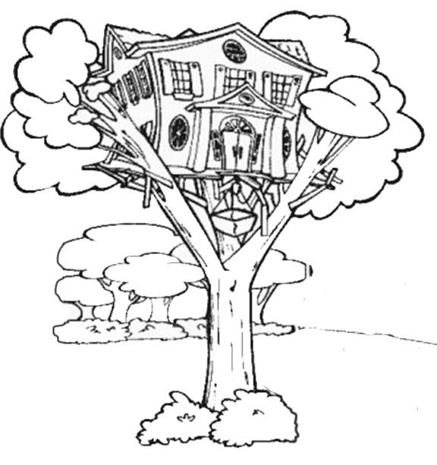
Part 1d of the project is a team-based activity.

It is now time to propose to Aunt Ada a collection of tree trunk designs along with a justification for each proposed design. As we discussed in class, this now essentially becomes a description of A(x), E(x), and P(x); however, as we also discussed, there is quite a bit of context behind these selections and you should therefore provide such context. Each student must prepare a proposal to include in the team’s report and the total text contributed by each student must be in the range of 150 – 200 words. Each student must be identified at the start of her or his writing.

At least one face-to-face meeting is required prior to submission of this part of the project. Your team should use the meeting to devise a strategy behind your collection of proposals; basically the idea is you want to provide Aunt Ada with some choice in the final design and you want a game plan, if you will, behind the choices presented to her. This strategy should be summarized for Aunt Ada in a paragraph that starts the team’s report; the summary should be in the range of 100 – 150 words. Creating the introductory paragraph (your strategy summary for Aunt Ada) should be a team writing effort; as such, you do not need to create minutes from the meeting – only the introductory summary.

Supporting figures are encouraged; hand sketches are fine but, as always, please submit as professional a quality as you can. The number of words on figures should be minimal; that said, words on figures do not count toward your word total. If necessary, include references at the end of your team report (again, they do not count toward the word count).

Proposal reports outside the prescribed word counts will have points deducted. All team members will share the same grade on the response.

“Understand well as I may, my comprehension can only be an infinitesimal fraction of all I want to understand.” - Ada Lovelace

